 | Proprietary  Information

Orbit Chat
User Guide

26th November 2019
Version 1.9
Contents
1 Introduction 4
2 How Orbit Chat is used 4
3 Installing Orbit Chat application 4
3.1 Download application 4
3.2 Permissions 4
4 Orbit Chat User Interface Overview 5
5 Configure Nickname of the User 7
5.1 The License 8
5.1.1 Obtaining the license file 8
5.1.2 Activate the license from the application’s menu 9
5.1.3 Checking the license information 9
6 Connect with Orbit Reader 20 unit 9
7 Using the Chat Features 11
7.1 Initiating a Communication 11
7.2 Send/Receive a message from Orbit Chat to OR-20 13
7.3 Send/Receive messages from OR-20 to Orbit Chat 13
7.4 Closing the connection 14
7.5 Resuming the connection automatically 14
8 Using the File Transfer Feature 14
8.1 Transfer a file from Orbit Chat to OR-20 14
8.2 Transfer a file from OR-20 to Orbit Chat 16
9 Using the Broadcast feature 16
9.1 Broadcast mode 16
9.2 Turning on/off Broadcast mode on OR-20 16
9.3 Limitations of using Broadcast mode 16
10 Chat History 16
10.1 Chat history on OR-20 17
10.2 Chat history on Orbit Chat 17
11 Languages and translations 17
12 Known Issues and Limitations 17
13 Troubleshoot 18
13.1 Unable to pair OR-20 unit with Android device 18
13.2 Not able to connect the OR-20 unit with Android device 18
13.3 Not able to send a message from OR-20 18
13.4 The received messages appear as non-English text 18
13.5 Not able to send a message from the Orbit Chat 18

Introduction
Orbit Chat™ is an Android application that enables deaf-blind users to communicate with other people at public places or at home using their OR-20.

This manual will first guide you through the installation of the Orbit Chat application on your Android phone/tablet, and then guide you through the basic usage of the chat feature.

Notes:
- This document also includes pictures of the Android application user interface. These are for illustrative purposes only. The actual user interface may vary
- This application works on Android version 4.4 or higher.

How Orbit Chat is used
Connect your OR-20 and the Orbit Chat application over Bluetooth. Once it is connected, you can start sending messages from the Android application to OR-20. Any message that you send from the application is shown on the braille display of connected OR-20. You can reply or send a new message from your OR-20 to the Android application. It will be shown on the screen of your Android phone.

Installing Orbit Chat application
This section captures details of installing the application on Android device. This section is useful for the person providing assistance to the deaf and blind user setting up the system. If you have purchased the bundle, then your Android tablet comes pre-installed and configured. In that case you can skip this section.

Download application
Download and install the Orbit Chat application (apk) file from the Playstore at https://play.google.com/store/apps/details?id=com.orbitchat

Permissions
While installing the Orbit Chat, the Android system will ask you to grant several permissions to the application. Orbit Chat needs the following permissions to run its functionalities:

- Access Bluetooth Settings: This permission is required so that if the Bluetooth is turned off at the time of using the Orbit Chat, it can request to turn on the Bluetooth.
- Approximate Location: This Permission is required because Android relies on the location services to retrieve the identity of the nearby Bluetooth devices.
- Storage: The application needs permission to create a log file. The application will not modify or delete any other storage contents.

Note: On denying any of the above permissions, the application will not work properly.

Orbit Chat User Interface Overview
When you run the Orbit Chat, the start-up screen looks like the screenshot that follows.

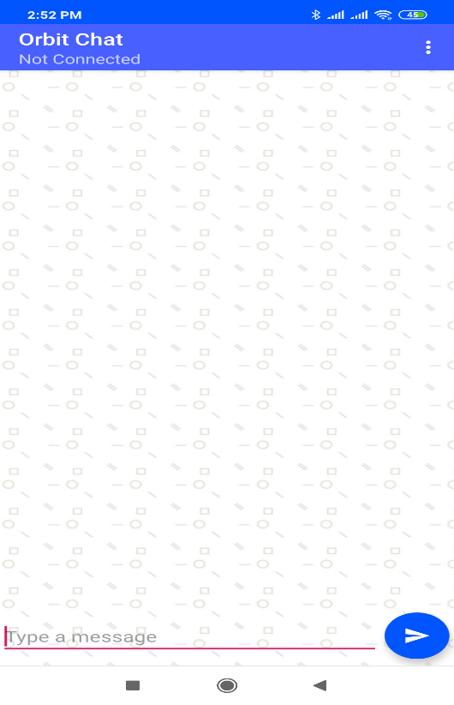
Figure 1
On the very top, there is a title bar. It displays the application name along with the connection status.

On the top right corner of the title bar, there is an “Option” menu which has the following sub-options.

- Change Nickname - To configure your nickname. Nickname is the name that appears with the message on receiving the OR-20 unit.
- Connect - To Initiate the connection process with the OR-20 unit
- Disconnect - To Disconnect with the currently connected OR-20 unit
- Send a file - To browse and send a file to connected OR-20 unit
- Show Braille-dots – By default the received messages are shown as English text and 8 dot Braille. You can disable the Braille output using this setting.
- Speak – Orbit Chat will speak out the received message. You can disable the speech output using this setting.
- Select Translation Table – To select the braille to text translation table for the respective language
- Activate License – To activate the license for a particular Orbit Reader 20 unit serial number
- Check License info – To check information about activated licenses on this app installation.
- Enable Logging – If you are facing some issues, our technical support team may advise you to enable this option so that a debug log is generated. This is for the use of our team to review the details of the issue you might be encountering. Unless suggested, you should keep this disabled.
- Version – To check the app’s version number

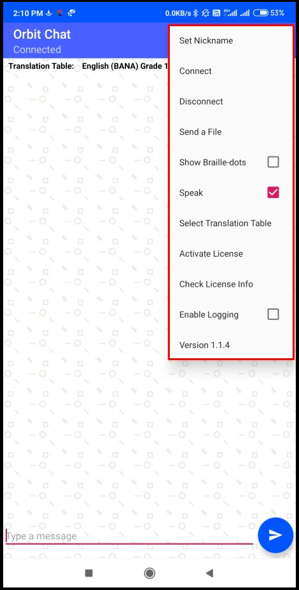
Figure 2
The OR-20 unit can be localized to any language in addition to the default language.

On the top of the home screen of Orbit Chat, there is a field showing the configured Translation Table language of the application. You should make sure that the typed language from OR20 and selected Translation table language should be matched. The messages may appear garbage otherwise. When no unit is connected, this field is hidden.

Below the Translation Table language, there is a display window that shows messages in chat style. The messages sent by you will appear on the right side of the window and the received messages will appear on the left side of the window. When no unit is connected, it displays nothing.

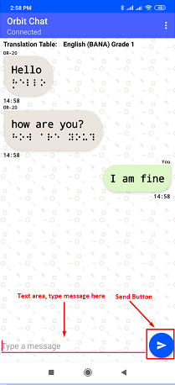
Figure 3
At the bottom, there is a text field where you can type the messages and a “send” button for sending message to connected OR-20 unit.

Configure Nickname of the User
The nickname is the name that appears along with your messages on receiving OR-20 unit. This helps the person operating the OR-20 unit to find out the sender’s name.

When you start the Orbit Chat for the first time, the Orbit Chat opens a dialog box for configuring nickname as shown in the image that follows.

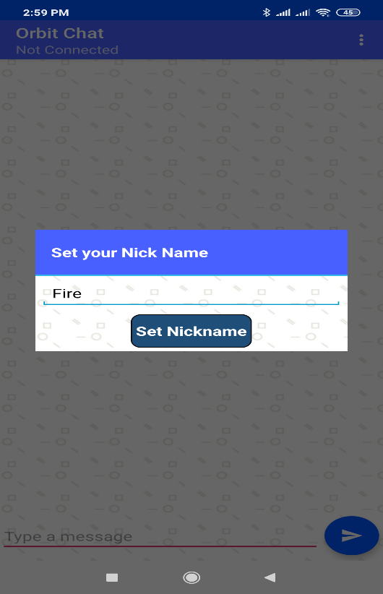
Figure 4
You can change the nickname later anytime as well. To change the already set nickname, go to the Options menu Change Nickname. The Orbit Chat opens a dialog box for configuring nickname.

Enter a nickname in the text area and click on the “Set Nickname” button to set your Nickname.

Nickname length cannot be more than 4 letters.

The License
The Orbit Chat app will not connect to Orbit Reader 20 without a valid license. It will show a message, “The license is not activated”.
The license activation process is divided into the following steps:
- Obtain your license file
- Activate the license from the menu

Obtaining the license file
Please contact us with the serial number for the Orbit Reader unit(s) which you plan to use with Orbit Teacher at techsupport@orbitresearch.com along with following information:
- Your Name
- Address
- Email Address
- Phone number
- Organization (If you represent an organization)
We will send you the license number over email within 3 business days.

Activate the license from the application’s menu
Open Options menu Activate License. It will open a field where you can enter the license key you have received. Please copy and paste the license key from your email and tap “Add License”
Upon successful activation, the app will show the message “License is valid from [start date] to [expiry date]. Otherwise, it will show the message “License activation error”.

Checking the license information
Open Options menu Check License info. It will open a message box with a list of the Orbit Reader 20 serial numbers for which licenses have been activated on the installed application.

Connect with Orbit Reader 20 unit
Connecting OR-20 with Orbit Chat may require assistance from the sighted person. But this is a one-time process. Once the connection is established, deaf-blind users can use it without any assistance required.

To connect to an OR-20 unit, go to the Options menu Connect. The Orbit Chat opens a new page showing a list of already paired devices available for the connection as shown in the image that follows. If your OR-20 unit Bluetooth name appears on the listed devices, click on the same to initiate the connection.

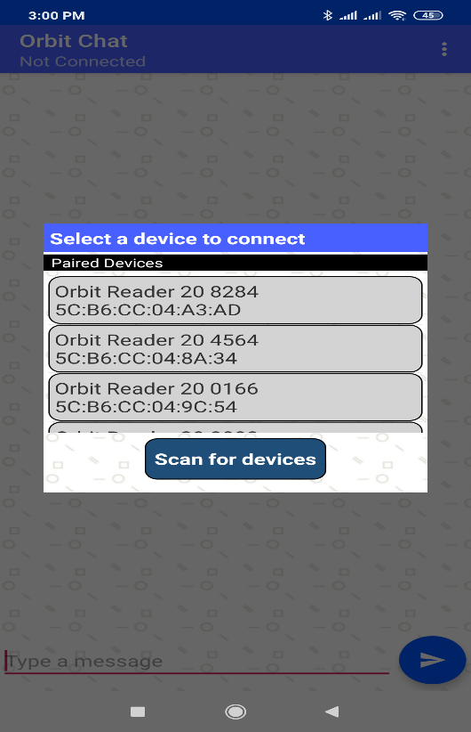
Figure 5
If your OR-20 unit is not paired already, it will not be shown on the list. You can click on the “scan for devices” button to initiate the first-time pairing. It will show all the unpaired OR-20 units within the available range.

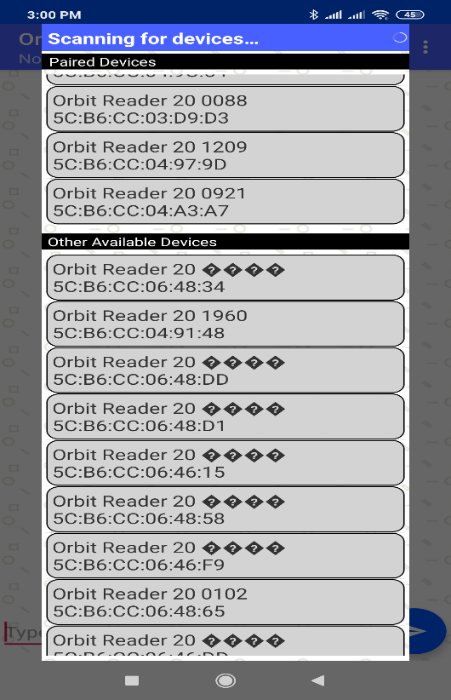
Figure 6
Click on the Bluetooth name of the OR-20 unit to initiate a connection. If that unit is not paired already, the Orbit Chat will generate a pop-up message asking to pair with the new OR-20 unit. Click on the “Pair” button of the pop-up message to establish the connection.

Upon successful connection between OR-20 and app, OR-20 shall enter into chat mode automatically and notify the user by blink the cursor on braille display.

To disconnect the OR-20 unit, click on the “Disconnect” button from the options menu. This will disconnect the unit and set the connection status to “Not Connected” in the action bar.

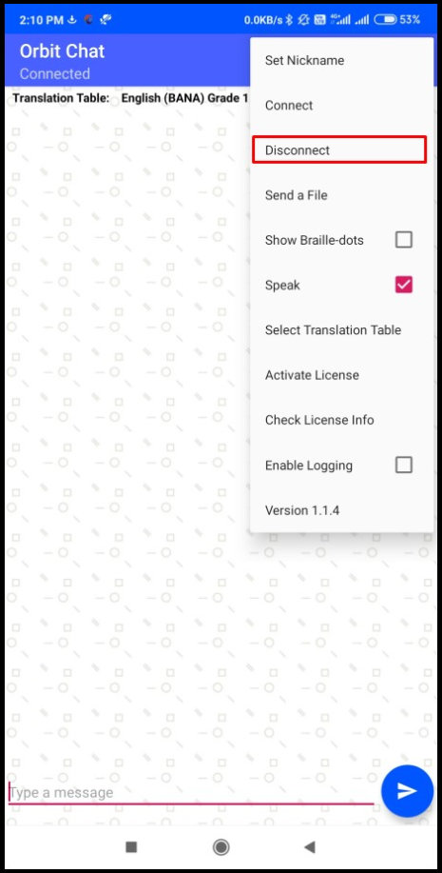
Figure 7

Using the Chat Features
Once connected, you can use the features described in the following sections

Initiating a Communication
A deaf-blind person would carry a set of OR-20 and an Android phone or tablet with them. Here the OR-20 and the Android device will be already paired and connected with the help of a sighted person and the application will be always running on the phone.
When a deaf-blind person wants to communicate with someone, they will unlock the phone and give their Android device to the person. When the other person looks at the phone screen, they will be greeted with a welcome note as shown in the screenshot below which says, “Hello, I am deaf-blind. I would like to talk with you through this app. Please tap the OK button to start the conversation. You can see in black text what I type on my device. Please type using the on-screen keyboard and I will be able to see it on my device in braille and can respond to you. “
Once the person clicks on “Ok”, they will see the home screen and chat can be initiated.
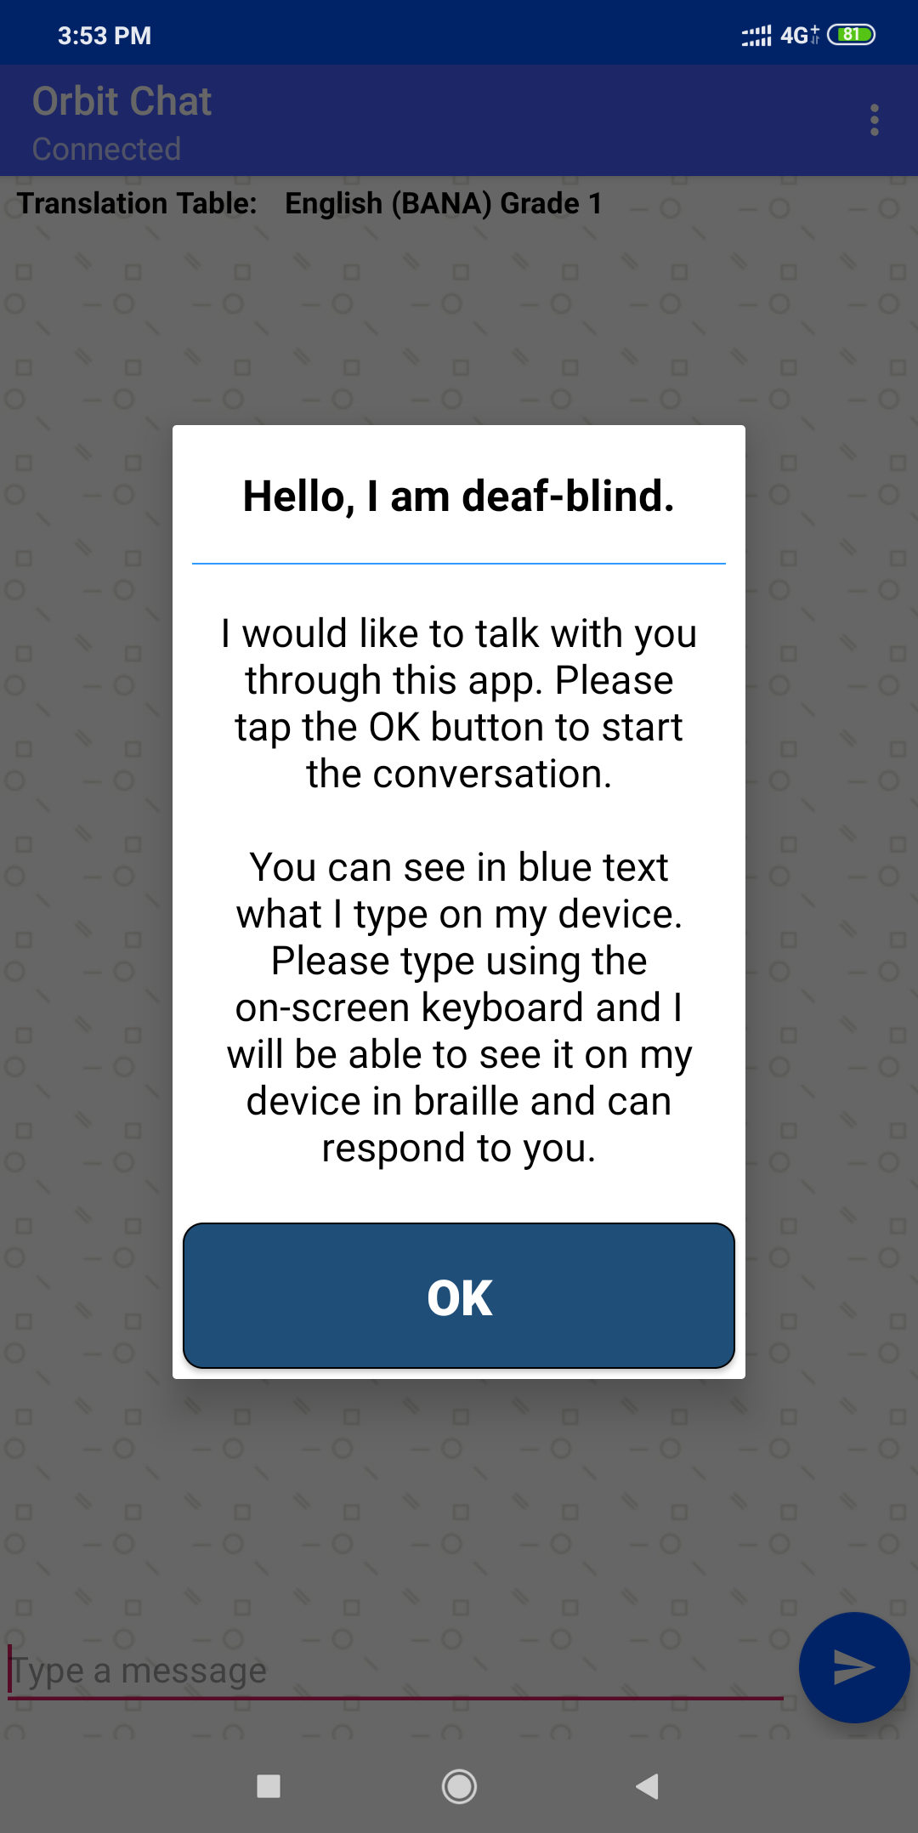
If for some reason, App is not connected to the OR-20 unit, the following message appears. In that case, a connection has to be established manually as described in section Connect with Orbit Reader 20 unit.
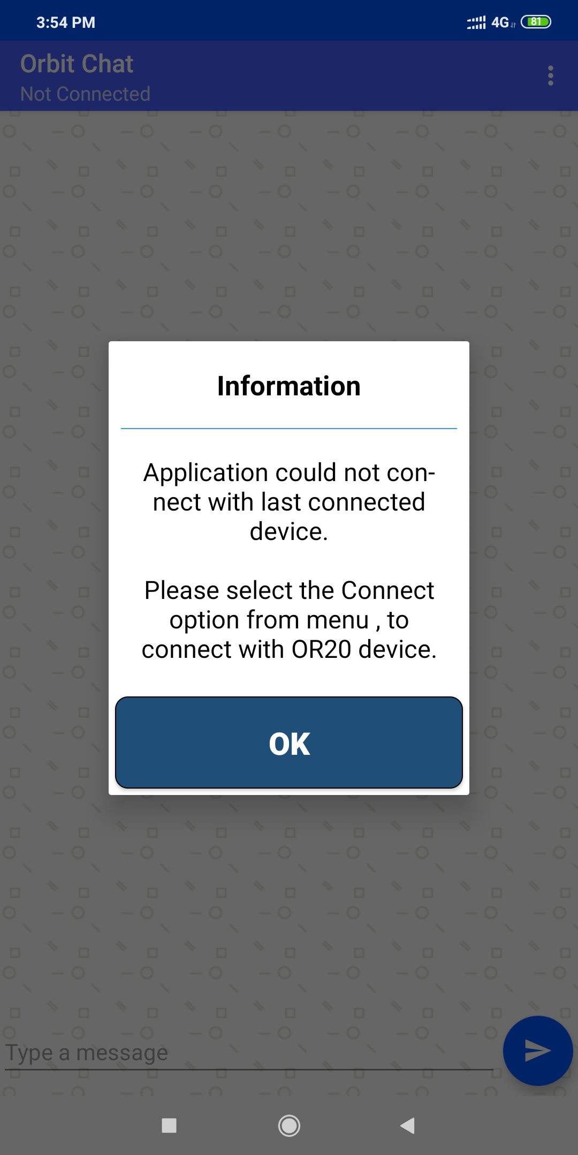

Send/Receive a message from Orbit Chat to OR-20
Chat can be initiated either by Orbit Chat or the OR-20. To initiate a chat from Orbit Chat, type your message in the message box at the bottom and click the “Send” button. The messages sent by you appears on the right side of the chat window. When you get a reply from the OR-20 unit, it appears on the left side of the chat window. A maximum of 100 characters are allowed in a single message.

Note: You will not able to send any message from Orbit Chat to OR-20 in Broadcast mode.

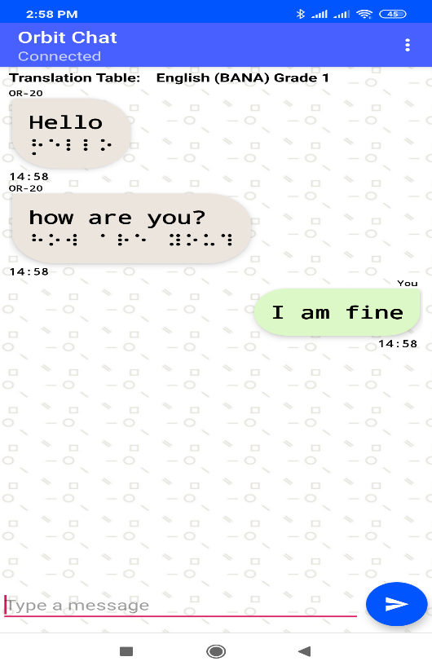
Figure 8

Send/Receive messages from OR-20 to Orbit Chat
To initiate a chat from OR-20 unit, enable the Chat mode by pressing “Space + dots 4-6”. It opens up an editor field with blinking cursor through dot 7 and dot 8 pins.

You can type your message and then press dot 8 to send the message to Orbit Chat. A maximum of 100 characters are allowed in a single message.

Similarly, when you receive any message on OR-20 unit from the Orbit Chat, it appears on your OR-20 for you to read. Press “dot 8” to reply to the received message or press “dot 7” to discard. Pressing dot 7 takes you back to what you were doing before the notification appeared on your display

To exit the chat mode press, “Space + Dots 4-6 again. It takes you back to your previous operating mode of the OR-20 unit.

Closing the connection
The connection to the Orbit Reader 20 is closed automatically when you put the Orbit Reader 20 to sleep, or turn it off.
The connection is also closed automatically when you close the app.
Note that the app and Orbit Reader 20 remains connected when you put the phone/tablet on standby (screen lock).
To manually disconnect app with Orbit Reader 20 using Orbit Reader 20 keypad, press SPACE + D (Dots 1 4 5 7). To manually disconnect from the app, Go to the menu and click on “Disconnect”.

Resuming the connection automatically
Orbit Reader 20 reconnects to the last connected host when you wake up Orbit Reader 20 from a sleep state or turn it on provided, the Phone/Tablet’s Bluetooth is ON and the Orbit Teacher app is running.
If you have locked the phone screen, while app was running, any activity on Orbit Reader 20 wakes the Phone/Tablet and re-connects.

To connect manually, follow the same process as you followed for the first-time connection except that you don’t have to pair again.

Using the File Transfer Feature
You can also send/receive a file from the android device to connected OR-20 unit and vice-versa using the Orbit Chat. It supports the transfer of TXT, BRF, BRA and BRL file types.

Note: File transfer from Orbit Teacher to OR20 and vice versa is not allowed when OR-20 Bluetooth broadcast mode is enabled.

Transfer a file from Orbit Chat to OR-20
To send a file from Orbit Chat to the connected OR-20 unit, go to the Options menu Send a file.
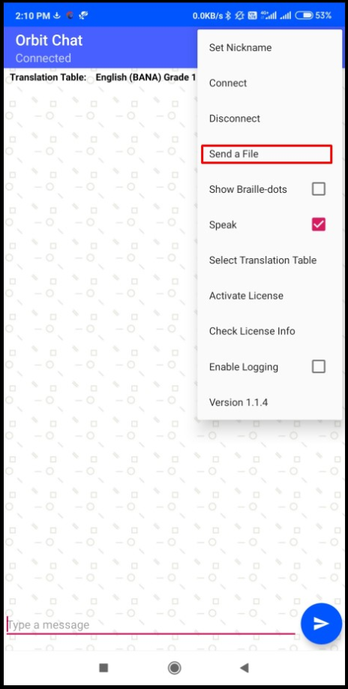
Figure 9
The Orbit Chat will open the system default file browser as shown in the image that follows.

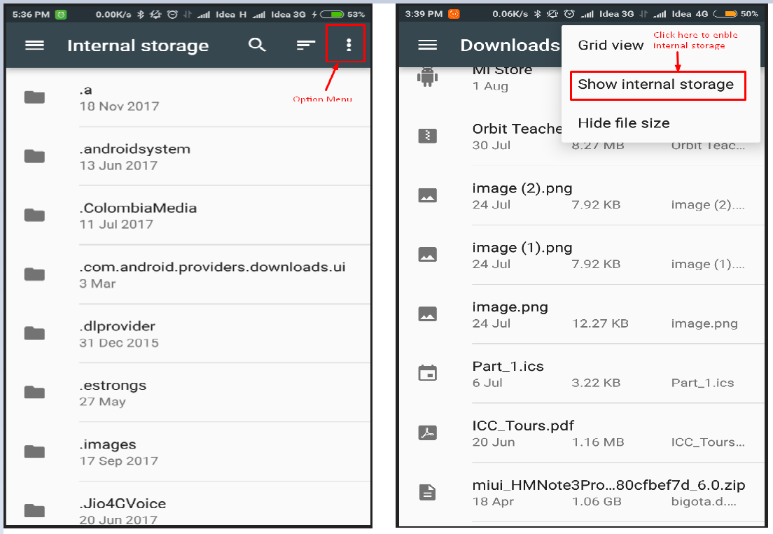
Figure 10
The file browser may not show the internal storage to the first-time user. To view internal storage in the file browser, go to the options menu (Top right of file browser) “Show internal storage”.

After selecting a file, the Orbit Chat opens a dialog box for the confirmation. Click on “Yes” to send a file to the connected OR-20 unit. OR-20 unit should display the confirmation message. Press dot 8 on OR-20 for receiving files from the Orbit Chat Application or press dot 7 on the OR-20 unit to reject the request.

The progress of the file transfer is shown through the progress bar and completion is indicated by a message saying “File transfer complete”.

Transfer a file from OR-20 to Orbit Chat
On OR-20 browse to a file from the file manager and press “Space + Dots 1-3-6-7” key combination to send a file from OR-20 unit to connected Android device. Orbit Chat should open a dialog for confirmation. Press the “Yes” button for receiving a file from the OR-20 unit or press the “No” button to reject the request.

The completion of the file transfer is indicated by a message saying “complete”.

Using the Broadcast feature

Broadcast mode
Broadcast mode allows OR-20 to be connected with up to 7 Orbit Chat application running on android over Bluetooth and send the typed message to all the connected Orbit Chat applications. This way you can send a message to multiple Android phones simultaneously. This feature can be enabled from OR-20.

Turning on/off Broadcast mode on OR-20
Broadcast feature of OR-20 can be turned on/off by hotkeys "Space + b" or "Space + Dots 1 2”. It shows the message “Broadcast On” or “Broadcast Off”.

Limitations of using Broadcast mode
The following are limitations of using the Broadcast mode of OR-20.
- All active Bluetooth connections are disconnected automatically when you switch between "Broadcast on" and "Broadcast off". You will have to initiate connection again from the application.
- File transfer is not allowed in Broadcast mode
- Messages can be sent only from OR-20 to connected applications and not the vice-versa.

Chat History
Orbit Chat application and the OR-20 unit automatically save the chat history.

Chat history on OR-20
The OR-20 device saves the “ChatHistory.txt” file at the root directory of the SD Card.

Chat history on Orbit Chat
The Orbit Chat application saves “ChatHistory_Orbit Reader 20 XXXX.txt” file into the Orbit Chat folder located at the internal storage of the android device.
Here, XXXX in the file name stands for the serial number of the OR-20 unit.

Languages and translations
From application side, user can type using any of the languages listed in following table. The message on the Orbit Reader 20 will be shown as uncontracted braille.
# | Supported Languages
1 | English
2 | Gujarati
3 | Bengali
4 | Hindi
5 | Kannada
6 | Malayalam
7 | Gurumukhi
8 | Oriya
9 | Tamil
10 | Telugu
11 | Greek
12 | Arabic
13 | Mongolian
14 | Hebrew

From Orbit Reader 20, user can type using any language listed in the menu “Select a translation table”. For proper translation appropriate language has to be set, message might appear garbage otherwise.

Known Issues and Limitations
- The connection will not resume automatically if the OR-20 unit was reset or turned off during active communication.
- If the connected OR-20 unit is turned off, the Orbit Chat will disconnect the device only after a few seconds.
- After the power cycle of OR-20 unit, sometimes the Orbit Chat might take multiple attempts to connect the OR-20 unit again.
- The file browser of the Orbit Chat does not support browsing directly from Google drive.
- If you disconnect from Orbit Chat while the chat mode is active on the OR-20 unit, it may show error message “SD error 35” sometimes.
- Orbit Chat can be connected to only one OR-20 at a time.
- If the Orbit Chat is running in the background, no notification is generated for the received messages.
- All active Bluetooth connections are disconnected automatically when you switch between "Broadcast on" and "Broadcast off". You will have to initiate connection again from the application.
- File transfer is not allowed in Broadcast mode
- You will not able to send any message from Orbit Chat to OR-20 in Broadcast mode.

Troubleshoot

Unable to pair OR-20 unit with Android device
Rebooting the android device, Reset the OR-20 unit and try again.

Not able to connect the OR-20 unit with Android device
- Make sure you are pressing dot 8 to accept the connection request within 30 seconds
- Reset the OR-20 unit and try again.

Not able to send a message from OR-20
- Make sure you have enabled chat mode on OR-20 unit and you are not on in file editor. you cannot send a message to Orbit Chat from the file editor. You can enable chat mode by pressing “dots 4-6 + space” key combination.
- Type a message on OR-20 unit and press dot 8 to send a message to Orbit Chat.

The received messages appear as non-English text
- Make sure default English is selected from the language selection menu on your OR-20 unit

Not able to send a message from the Orbit Chat
- Make sure you have not typed any emoji or smiley in the message.
- Make sure the OR-20 unit is connected with Orbit Chat.

