Proprietary
Information

Orbit Reader 20™
Bootloader Upgrade Utility
User Guide

31st May 2019
Version 1.0

Table of Contents
1 Introduction 3
2 Installing the Bootloader Upgrade Utility 3
3 Bootloader Upgrade Procedure 6
3.1 Step 1: Prepare the device for upgrading 6
3.2 Step 2: Upgrade the bootloader 8
4 Troubleshooting 10

Introduction
The Orbit Reader 20 includes a mechanism to allow upgrading the system’s software. This is known as the bootloader. In some instances, the bootloader itself may need to be upgraded. This document describes the procedure for upgrading the bootloader.

The upgrade of the bootloader is performed by a Windows program known as the Bootloader Upgrade Utility. This program can work with Windows 8 and later versions.

This manual will first guide you through the installation of the Windows program, and then guide you through the bootloader upgrade process.

Notes:
- This document also includes pictures of the Windows user interface. These are for illustrative purposes only. The actual user interface may vary.
- In this document, software version numbers are indicated by vXX.XX.XX.XXXXX, for instance, vB0.00.00.01b00.

Installing the Bootloader Upgrade Utility
- Download the Bootloader Upgrade Package from the website (https://www.orbitresearch.com/support/orbit-reader-20-bootloader-upgrade-package).
- Run the program “OR-20 Bootloader Upgrade Package Setup vXX.XX.XX.XXXXX.exe” to install the bootloader upgrade program.
- Program installation asks for administrative privilege.
- When the installation begins, you will find a checkbox on the first screen to create a desktop shortcut for the program as shown in Figure 1. By default, this checkbox will be checked. Click the “Next” button to start the installation process.

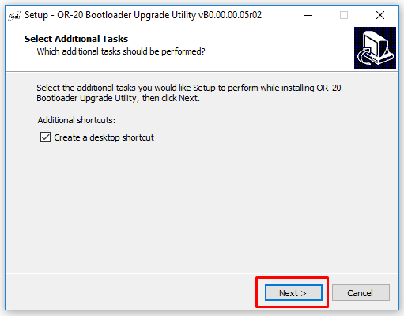
Figure 1
- Click on the “Install” button to continue with the installation.
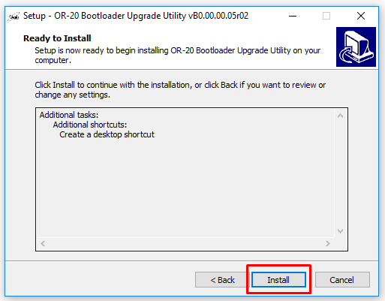
Figure 2
- Please wait while Setup installs the program on your computer.
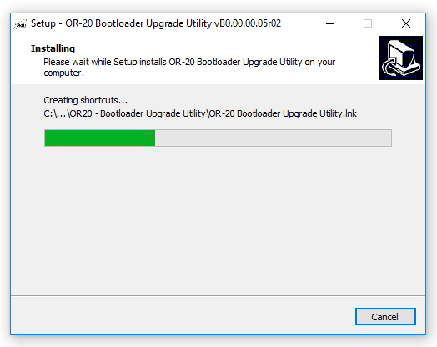
Figure 3
- Click on the “Finish” button to exit the setup. To launch the program after exiting the setup check the checkbox “Launch OR-20 - Bootloader Upgrade Utility”. By default, this checkbox will be checked. See Figure 4.
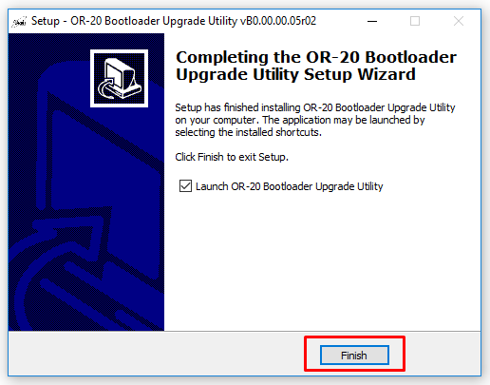
Figure 4

Bootloader Upgrade Procedure
- Once the installation is complete, run the “OR-20 Bootloader upgrade utility” from the start menu or using the shortcut created on the desktop by the installer.
- The upgrade process is divided into two steps:
Step 1: Prepare the device for upgrading
Step 2: Upgrade the bootloader
Normally, these two steps will directly follow each other.

Step 1: Prepare the device for upgrading
  - Connect the OR-20 to the PC using the supplied micro-B USB cable.
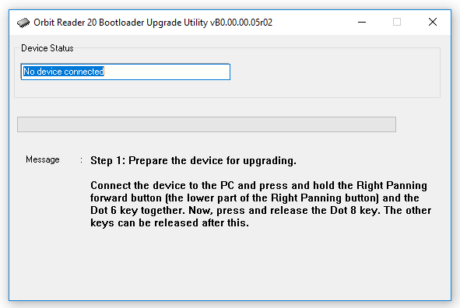
Figure 5
  - Press and hold the Right Panning forward button (the lower part of the Right Panning button) and the Dot 6 key together.
  - Now, press and release the Dot 8 key. The other keys can be released after this.
  - The program will now begin preparing the device for upgrade. This might take up to 10 seconds. Figure 6 shows a screenshot of the program at this stage.
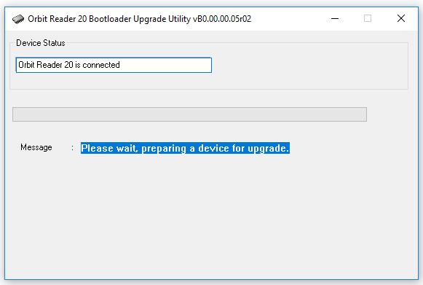
Figure 6

  - When the preparation is complete, the program will show the message “The device is ready for upgrade” as shown in Figure 7.

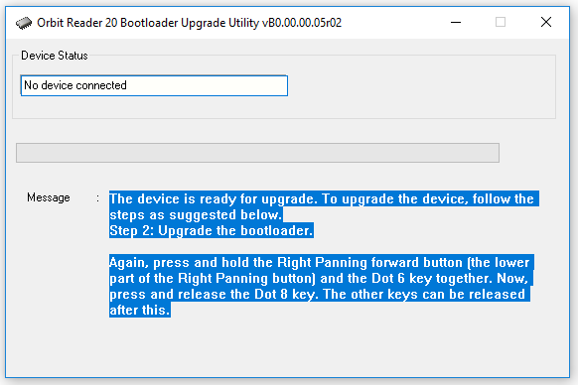
Figure 7

  - If an error is encountered in preparing the device for upgrade, the program will show “Unable to prepare the device for upgrade” as shown in Figure 8. In this case, please repeat Step 1 until the program shows “The device is ready for upgrade”.
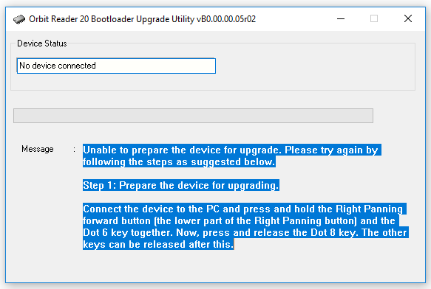
Figure 8

Step 2: Upgrade the bootloader
- Press and hold the Right Panning forward button (the lower part of the Right Panning button) and the Dot 6 key together
- Now, press and release the Dot 8 key. The other keys can be released after this.
- The program will begin the upgrade process and will take about 30 seconds to complete. Figure 9 shows the screenshot of the program while upgrading the bootloader of the OR-20.
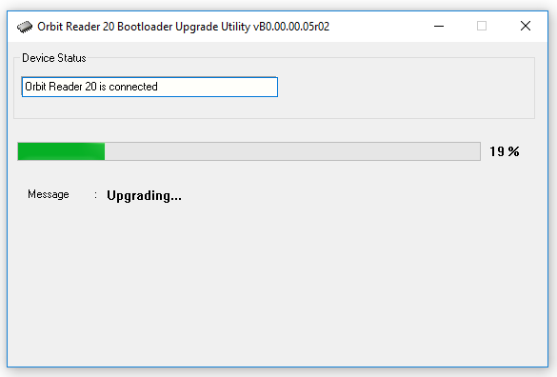
Figure 9
- The windows program shows the message “The device successfully upgraded to bootloader version vXX.XX.XX.XXXXX” after a successful upgrade. See Figure 10.
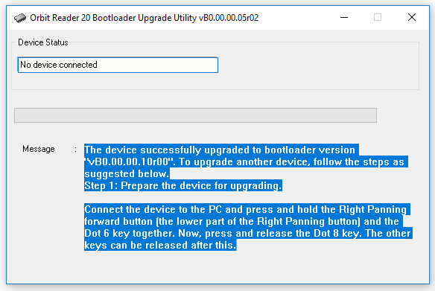
Figure 10
- In case of an error, the program will show the message “Failed to upgrade bootloader” as shown in Figure 11. Please repeat Step 2 until you get the successful message.
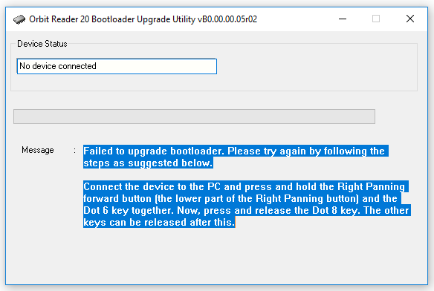
Figure 11

Troubleshooting
- Sometimes the OR-20 may not enter the preparing stage. If that happens, make sure you follow the correct sequence of the keys. Press and hold the Right Panning forward button (the lower part of the Right Panning button) and the Dot 6 key together, without releasing them. Then press and release the Dot 8 key. After releasing the Dot 8, you can release the other keys.
- If the step 1 of the process was already performed successfully earlier, and if you try to repeat the process, it will skip step 1 and directly jump to step 2.
- If you are not sure what stage of the upgrade process you are at, you can always start from the first step. Just reset the OR-20 by pressing the Right Panning forward key and Dot 8. Close and run the PC program again.

Revision History
Rev. | Date | Description of Changes | Author
0.1 | 1st May 2019 | Created | Orbit
0.2 | 2nd May 2019 | Updated | Orbit
0.3 | 16th May 2019 | Updated | Orbit
0.4 | 20th May 2019 | Added troubleshooting steps | Orbit
0.5 | 20th May 2019 | Updated | Orbit
0.6 | 20th May 2019 | Updated | Orbit
0.7 | 21st May 2019 | Updated | Orbit
0.8 | 21st May 2019 | Updated | Orbit
0.9 | 22nd May 2019 | Updated | Orbit
0.10 | 22nd May 2019 | Updated | Orbit
0.11 | 23rd May 2019 | Updated | Orbit
0.12 | 24th May 2019 | Updated | Orbit
0.13 | 29th May 2019 | Updated | Orbit
0.14 | 30th May 2019 | Updated | Orbit
0.15 | 31st May 2019 | Updated | Orbit
1.0 | 31st May 2019 | Updated | Orbit

