
Orbit Reader Q20™ and Q40™
Quick-start Guide

Introduction
This guide provides the basic instructions for using the Orbit Reader Q20 and Q40 Electronic Braille Display. For more information and complete instructions, consult the Orbit Reader Q20 and Q40 User Guide included on the SD card.
The Orbit Reader Q20 and Q40 are unique 3-in-1 devices that enable a blind or visually impaired user to read books and documents in braille, take notes and save them as braille or text files. It helps the user to easily access all the functions of a computer or smartphone such as web browsing, email, and text messaging.
Reading materials that were previously available in braille embossed on paper, can now be read on the compact and portable Orbit Reader Q20 or Q40. Thousands of books can be stored on small memory cards, known as SD cards. Blind people who used to write notes using a slate and stylus or a Perkins Brailler can now type in braille with the Orbit Reader Q20 or Q40, which includes a QWERTY keyboard and is much quieter and faster, as well as being fatigue-free. The notes are stored on the SD card and can be transferred to a computer or smartphone and read by anyone.
The Orbit Reader Q20 and Q40 produce braille symbols using 8 pins that can move up and down to produce braille dots and can show a line of 20 such symbols in Orbit Reader Q20 and 40 such symbols in Orbit Reader Q40, also known as cells. Any text or braille content can be instantly displayed on the device, 20 symbols at a time in Orbit Reader Q20 and 40 symbols at a time in Orbit Reader Q40 and once you have read the first line, you can move to the next line by pressing a button, known as the pan button.

In the Box
The following items are included in the package. Contact your distributor if anything is missing or damaged.
- Orbit Reader Q20 or Orbit Reader Q40 unit
- Charger
- USB Cable (USB-A to USB Type C)
- SD Card with User Guide and content (installed in unit)
- Printed Quick-Start Guide

Orientation of the Device

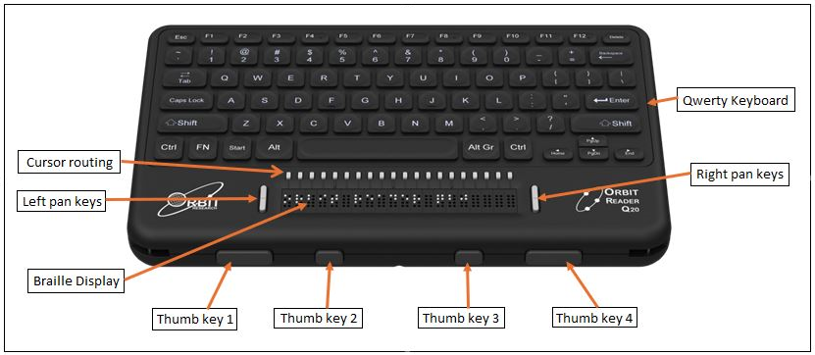

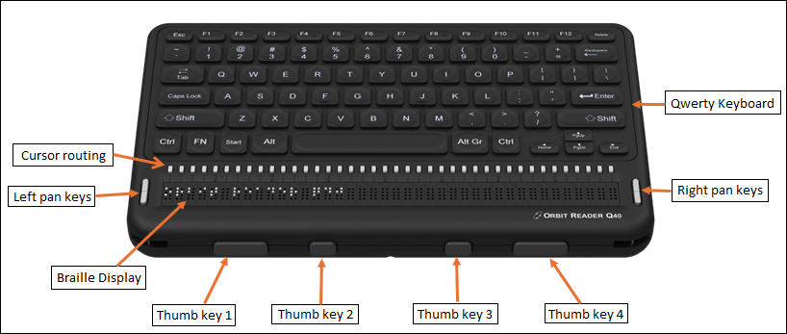
The normal operating orientation of the device is with the four Thumb keys closest to you. Above the Thumb keys is the line of braille cells. On the left and right side of the braille line are two buttons. These buttons are used to skip to the next or previous line of braille and are known as the pan keys. ￼
The small buttons located above each braille cell are cursor routing buttons, used to move the cursor to the desired location while editing. Above the cursor routing keys is the QWERTY keyboard. The QWERTY keyboard is used for entering commands and writing data in the file.

On the right side of the device, from front to back, is the recessed Power button (front), USB Type-C (middle), and 3.5mm Audio Jack (back).
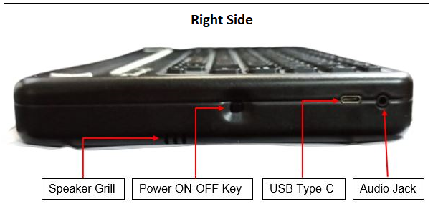

On the left side of the device, is the Standard USB A host port.
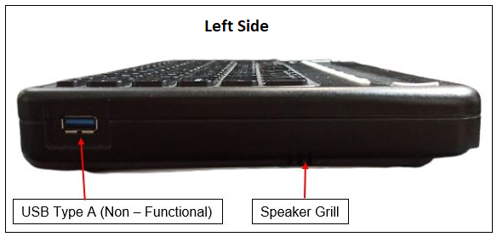
At the back side of the device, is the SD card slot
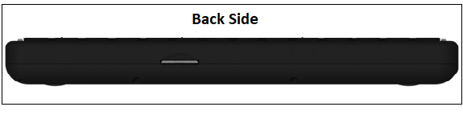
. At the bottom of the device, is the switch to Power cut-off of the device.
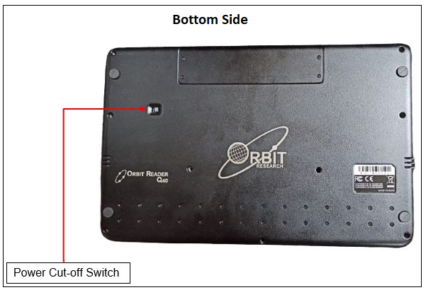

Charging the Device
We recommend charging the device fully before or during the first use. To charge the battery, plug the small end of the cable into the USB Type C port on the right side of the unit and insert the other end into the supplied charger or a USB port on a computer.

Powering On and Off
To turn on the device, press and hold the power button for 2 seconds. If the device is already on, pressing and holding the power button for 2 seconds will turn it off. If the device is running on batteries and you do nothing with it for 10 minutes, it goes to sleep automatically to conserve power. The device will activate all the dots momentarily to indicate power-on and power-off.

Language Settings
Your Orbit Reader Q20 and Q40 come with support for several languages and more can be loaded from the SD card as needed. You can select a language by pressing the Alt key and one of the Function keys together. The Alt + F1 keys will choose UEB Grade 1 (uncontracted) braille for reading and writing. All the messages and menus will also be shown in UEB Grade 1 (uncontracted). The Alt + F2 keys will choose UEB Grade 2 (contracted). The Alt + F3 keys will choose the BRF format, which is independent of language. The Alt + F4 keys will choose the language you have loaded from the SD card. Many other options provide a lot of flexibility. Please refer to the User Guide for more details.

Reading
The Orbit Reader Q20 and Q40 come with an inserted SD card containing the User Guide and translated braille material already on it. If the SD card is removed or there is no SD card present when the unit is turned on, the Orbit Reader Q20 or Q40 displays “SD card [no media]”. To insert a card into the slot, make sure its contact fingers are facing down and gently push it in until you hear or feel a click. To remove a card, press and release it.
When you first power the device on, the display shows the name of the first file or folder on the SD card. You can scroll through the list of files using the Up and Down Arrow keys on the QWERTY keyboard.
To open a file in the list for reading, press the Enter key. To read a file, use the panning buttons to move forward or back through the contents forty characters at a time. To exit from reading a file and return to the list of files and folders, press the Backspace key.

Creating and Editing Files
To create a new file, press the CTRL + N. You will notice that dots 7 and 8 (the two dots at the bottom) in the first cell will start blinking. This is known as the cursor and shows the position at which the text you type will be inserted. Start typing using the QWERTY keyboard keys. Choose the language you would like to type in, using the Alt + F1 to F4 keys.
To edit a file you are reading, press the CTRL + E.
To exit the Editor, press the ESC key and then press Enter key. The cursor disappears and returns you to the file you were reading. If you have created a new file, the editor automatically names the file with the first 40 characters of the file. You can rename the file if you like.

Setting Preferences
The Orbit reader Q20 and Q40 offer several options which are accessed through the menu. This allows you to do things such as checking the battery status, configuring the way braille is displayed, etc.
- To see the menu, press the Windows + P key
- To move through the menu items, press Up or Down Arrow keys
- To see the options for an item in the menu, press Right or Left Arrow keys
- To select or unselect an option, press the Enter key
- To close the Menu, press the Backspace key

Connecting to a Computer or Smartphone
The Orbit Reader Q20 and Q40 can connect to computers and mobile devices to access all their functions and features using Braille. The connection can be either through USB or Bluetooth. The access to the computer or mobile device’s features is through a software program called a Screen Reader. This software is available for all platforms including Android, iOS, Windows, Mac OS, Chrome, and Amazon Fire OS and has been fully tested to operate seamlessly with the Orbit Reader Q20 or Q40. For further details, please refer to the User Guide.

Further Information
For the latest information, specifications, troubleshooting tips, software upgrade instructions, care and use information, warranty information, and more detailed instructions, contact us at techsupport@orbitresearch.com.

© 2021 Orbit Research. All rights reserved.

