Proprietary
Information

Orbit Chat
Bundle User Guide

15th July 2026
Version 0.9
Contents
1 Introduction 4
2 Basic use of the Orbit Chat system 4
2.1 Wake up the Android tablet 4
2.2 Turn on Orbit Reader 4
3 The User Interface for the Orbit Chat app 5
4 Using the Chat Features 8
4.1 Configure Nickname of the User 8
4.2 Initiating Communication 9
4.3 Send/Receive messages from Orbit Chat to Orbit Reader 11
4.4 Send/Receive messages from Orbit Reader to Orbit Chat 12
4.5 Closing the connection 13
4.6 Resuming the connection automatically 13
4.7 Connect with Orbit Reader unit from Orbit Chat 13
5 Using the File Transfer Feature 15
5.1 Transfer a file from Orbit Chat to Orbit Reader 15
5.2 Transfer a file from Orbit Reader to Orbit Chat 17
6 Using the Broadcast feature 17
6.1 Broadcast mode 17
6.2 Turning on/off Broadcast mode on the Orbit Reader 17
6.3 Limitations of Broadcast mode 17
7 Chat History 18
7.1 Chat history on Orbit Reader 18
7.2 Chat history on the Orbit Chat app 18
8 Languages and translations 18
9 Upgrade Orbit Chat application 18
9.1 Disable Launcher mode 18
9.2 Download application 19
9.3 Copy the application to the tablet from a PC 19
9.3.1 Transfer APK file from Windows PC to Android Tablet 19
9.3.2 Transfer APK file from Mac book to Android Tablet 19
9.4 Install 20
9.5 Permissions 20
9.6 Enable Launcher mode 20
10 Enable/Disable TalkBack 20
10.1 Enable Talkback 20
10.2 Disable TalkBack 20
10.3 Enable/Disable Talkback using shortcut 21
11 Known Issues and Limitations 21
12 Troubleshooting 22
12.1 Unable to pair Orbit Reader unit with Android Tablet 22
12.2 Not able to connect the Orbit Reader unit with Android Tablet 22
12.3 Not able to send a message from Orbit Reader 22
12.4 The received messages appear as non-English text in Orbit Chat 22
12.5 Not able to send a message from Orbit Chat 22
12.6 TalkBack is getting connected with Orbit Reader instead of connect with Orbit Chat. 22

Introduction
Orbit Chat™ is a system comprising of an Android application and the Orbit Reader braille display that enables deafblind users to communicate with other people at public places or at home.

This manual will guide you through the use of the Orbit Chat system. It first describes the basic usage, then the user-interface, the features in detail and finally, tips on troubleshooting.

Notes:
- This document also includes pictures of the Android application user interface. These are for illustrative purposes only. The actual user interface may vary.
- This application works on Android version 4.4 or higher.

Basic use of the Orbit Chat system
Unbox the Orbit Chat bundle. The package contains the following:
- The Orbit Reader unit with SD card installed
- An Android tablet, pre-configured with the Orbit Chat app
- A USB charger
- A charging cable
When you receive the bundle, the Orbit Reader will be in the powered-off state and the Android tablet will be in standby mode.

Wake up the Android tablet
Wake up the Android tablet by applying a single tap on its power button. If for some reason the Android tablet is in the OFF state, turn it on by holding down the power button for 40 seconds until your Android tablet powers on. Once it powers on, release the power button. If it doesn’t power on after 40 seconds, release the power button and press it again to turn on your Android tablet. It may also be necessary to charge the tablet.

Turn on Orbit Reader
Once you turn on the Orbit Reader, it will automatically connect with the Orbit Chat App provided the Android Tablet is in On or Standby state.
Upon successful connection with Orbit Chat, the Orbit Reader will enter into chat mode automatically and starts blinking the cursor at the first cell of the Orbit Reader’s braille display.
The Android Tablet will wake up automatically if it is in Standby mode. Swipe up the Android tablet screen to unlock the tablet. Once the Android tablet is unlocked, the Welcome message will be visible on the tablet screen. Press “OK” to continue.
Now, you can start sending messages from Orbit Chat to the Orbit Reader and vice-versa.
Any message that you send from the Orbit Chat app is shown on the braille display of the connected Orbit Reader. You can also reply or send a new message from your Orbit Reader to the Orbit Chat app. It will be displayed on the screen of your Android tablet.

The User Interface for the Orbit Chat app
When the Orbit Chat app is first run, a Welcome screen pops up, informing a sighted or blind user about the purpose of the app. The screenshot below shows the Welcome screen.

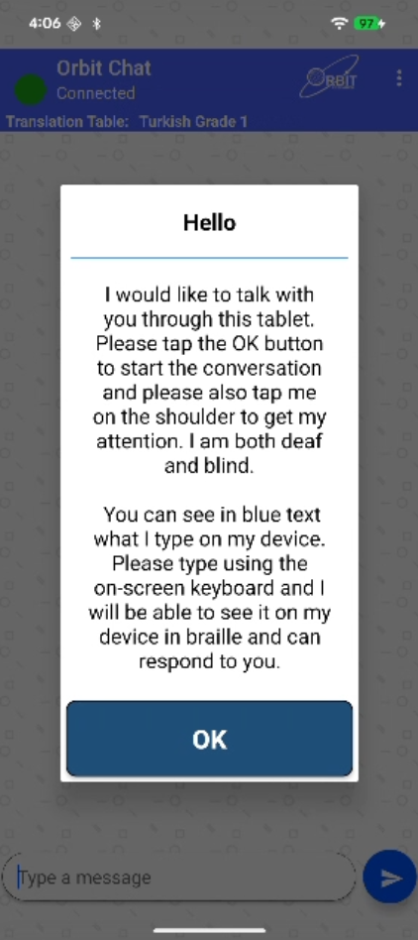
Figure 1

Once the Welcome screen is dismissed by tapping the “OK” button, the start-up screen is displayed and looks like the screenshot below.

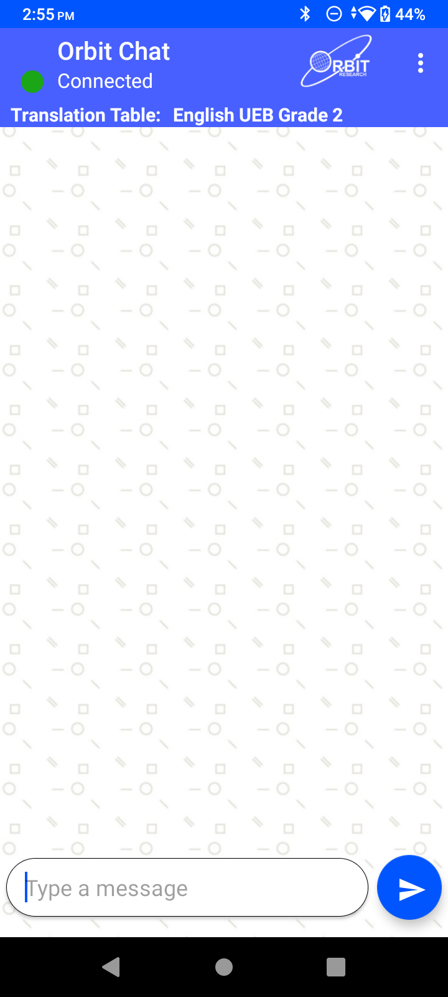
Figure 2
At the very top is a title bar. It displays the application name along with the connection status.

On the top right corner of the title bar, is an “Option” menu (indicated by the three vertical dots). Tapping on this following options are displayed on the screen:

- Change Nickname – Tap on this to configure a nickname for the person using the tablet. The nickname appears at the beginning of each message received and displayed on the Orbit Reader unit.
- ReConnect – This initiates the connection process with the last connected Orbit Reader unit.
- Connect – This initiates the connection process with the Orbit Reader unit.
- Disconnect - This disconnects the currently connected Orbit Reader unit.
- Send a file – This allows browsing for and sending a file to the connected Orbit Reader unit
- Show Braille-dots – By default, received messages are shown on the app as English text and 8-dot Braille symbols. You can disable the Braille output on the app using this setting.
- Select Translation Table – To select the braille to text translation table for the language in use.
- Accessibility Settings – To open the Accessiblity Setting page of the Tablet.
- Version – To check the app’s version number.

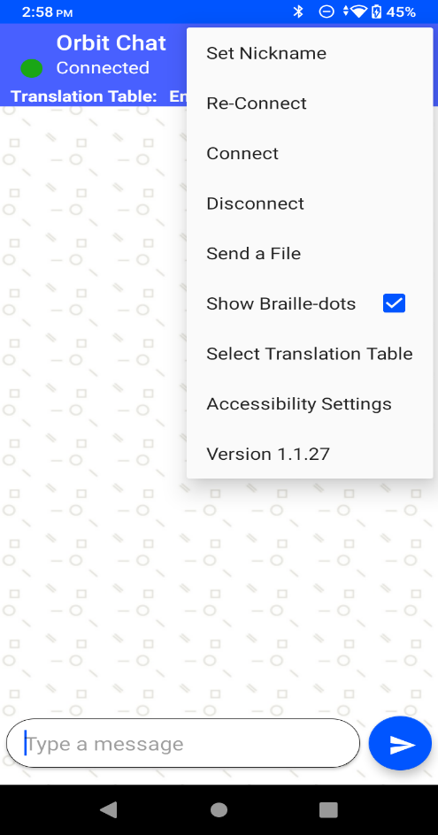
Figure 3
The Orbit Reader unit can be localized to any language in addition to the default language.

At the top of the home screen of the Orbit Chat app is a field showing the configured Translation Table language. You should make sure that the language typed on the Orbit Reader and the selected Translation Table language are matched. The messages may appear garbled otherwise. When no unit is connected, this field is hidden.

Below the Translation Table language, is a display window that shows messages in chat style. The messages sent by you from the tablet will appear on the right side of the window and the received messages will appear on the left side of the window. When no unit is connected, nothing will be displayed.

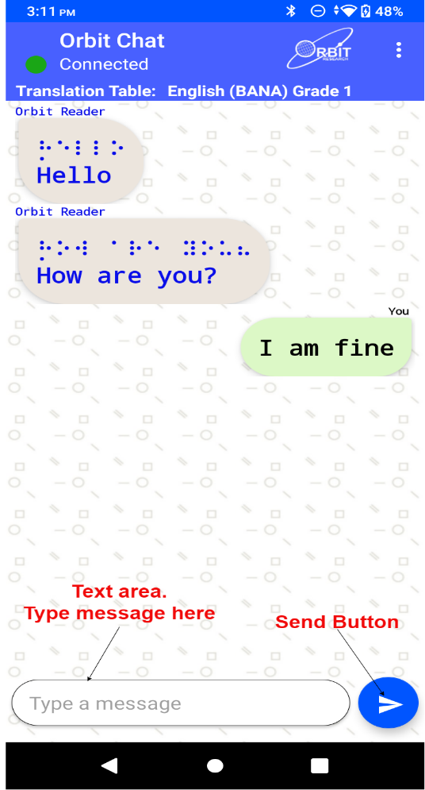
Figure 4
At the bottom is a text field where you can type the messages and a “send” button to send the message to the connected Orbit Reader unit.

Using the Chat Features
The Orbit Chat provides several features. These become available once the app is connected to an Orbit Reader and are described in the following sections.

Configure Nickname of the User
The nickname is a name that appears along with your messages on the connected Orbit Reader unit’s braille display. This helps the person operating the Orbit Reader unit to know the sender’s name.

To set the Nickname, go to the Options menu à Set Nickname. Orbit Chat opens a dialog box for configuring the nickname as shown in the picture below.

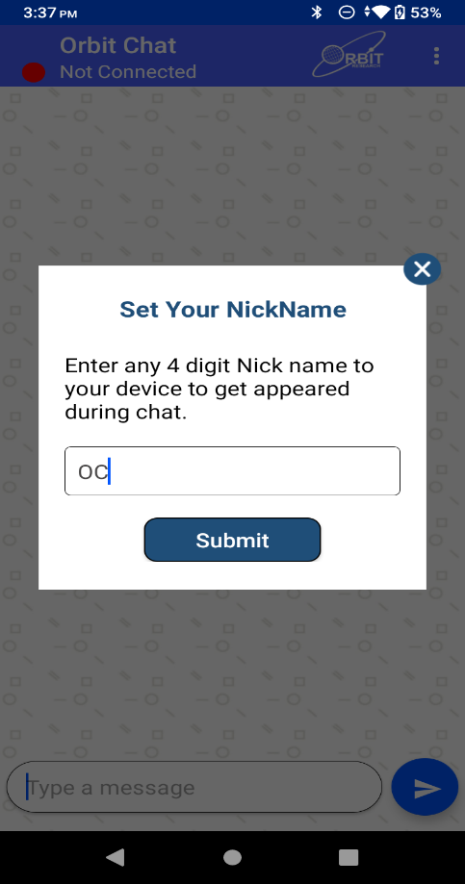
Figure 5

Enter a nickname in the text area and tap on the “Set Nickname” button to set your Nickname. If you do not want to set a nickname then leave the nickname as blank in the nickname text area and tap on the “Set Nickname” button.

The length of the nickname cannot be more than 4 letters.

Initiating Communication
When a deafblind person wishes to initiate communicate, they will unlock the Android Tablet and give it to the person with whom they wish to communicate. When the other person looks at the phone screen, they will be greeted with a welcome note as shown in the screenshot below which says, “Hello, I would like to talk with you through this tablet. Please tap the OK button to start the conversation and please also tap me on the shoulder to get my attention. I am both deaf and blind. You can see in black text what I type on my device. Please type using the on-screen keyboard and I will be able to see it on my device in braille and can respond to you.”
Once the person taps “OK” on the tablet, they will see the home screen and chat can be initiated.
Figure 6

If for some reason, Orbit Chat is not connected to the Orbit Reader unit, the following message appears. In this case, a connection has to be established manually as described in the section “Connect with Orbit Reader unit from Orbit Chat“.
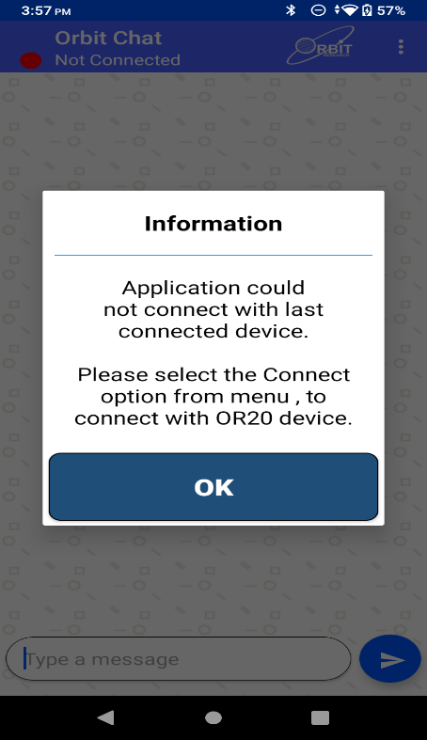
Figure 7

Send/Receive messages from Orbit Chat to Orbit Reader
A chat session can be initiated either from the Orbit Chat app or from the Orbit Reader. To initiate a chat session from the Orbit Chat app, type your message in the message box at the bottom of the screen and tap the “Send” button. The messages sent by you appear on the right side of the chat window. When you receive a reply from the Orbit Reader unit, it appears on the left side of the chat window. A maximum of 1000 characters are allowed in a single message.

Note:
- The Orbit Chat user cannot type a message while the Orbit Reader user is typing a message. In this case, the application will not allow typing and will display the message “Orbit Reader typing”. In case, Orbit Reader user does not type for 10 seconds then time out will occur, and the application will allow typing and display the message “Type a message”.
- When Orbit Reader is in standby, the Orbit Chat app will display the message “OR-20 in Standby mode.” and will not allow the user to type any message. Tap on power on key to exit the standby status of Orbit Reader.
- You will not be able to send any message from Orbit Chat to the Orbit Reader in Broadcast mode. The details of Broadcast mode are covered in a later section of this document.

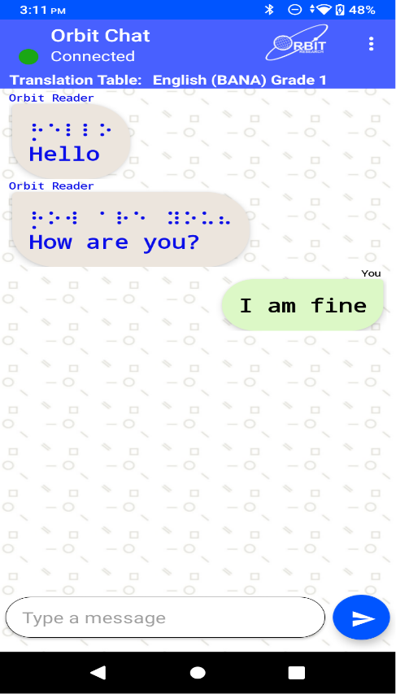
Figure 8

Send/Receive messages from Orbit Reader to Orbit Chat
To initiate a chat session from the Orbit Reader, enable Chat mode by pressing “Select + Dots 4-6”. This opens up an editor field with a blinking cursor (dots 7 and 8).

You can type your message and press dot 8 to send the message to the Orbit Chat app. A maximum of 1000 characters are allowed in a single message.

When you receive a message on from the Orbit Chat app, it is displayed on your Orbit Reader’s braille display. Press the Dot 8 key to reply to the received message or press the Dot 7 key to discard it. Pressing the Dot 7 key takes you back to what you were doing before the notification appeared on your display.

While sending or receiving messages, the Orbit Reader cannot be put into sleep mode using the power key, nor does it enter auto sleep. However, after discarding the received message by pressing the Dot 7 key, the Orbit Reader can then be put into sleep mode.

To exit chat mode press “Select + Dots 4-6 again. This takes you back to the previous operating mode on the Orbit Reader unit.

Notes:
- The Orbit Reader user cannot type a message while the Orbit Chat user is typing a message. In this case, the Orbit Reader will not allow typing and will display the message “[Nickname]: Typing.”. In case Orbit Chat user does not type for the 10 seconds then time out will occur and Orbit Reader will allow typing and display the typed message with a blinking cursor.”
- When Android tablet is in standby, Orbit Reader will display the message “Device locked” and when it exits from the standby, Orbit Reader will display the message “Device unlocked”. Press Dot 7 key to discard the message.
- When the tablet is in Standby Mode (screen lock), if the Orbit Reader user sends a message, the tablet will wake up automatically but needs to be unlocked by swiping up on the tablet’s screen.

Closing the connection
The connection to the Orbit Reader is closed automatically when you turn off or reset the Orbit Reader.
Note that the Orbit Chat app and the Orbit Reader unit remain connected when you put the phone/tablet on standby (screen lock) or the Orbit Reader in sleep mode. If you wish to connect to TalkBack or any other screen reader, the screen reader can be connected to the Orbit Reader.
To manually disconnect the app from the Orbit Reader using Orbit Reader keypad, press SPACE + Dots 1 4 5 7. To manually disconnect from the Orbit Chat app, go to the Options menu and tap on “Disconnect”.
When the application is in the foreground, the Android phone/tablet will not automatically enter sleep mode.

Resuming the connection automatically
The Orbit Reader reconnects to the last connected phone/tablet when it is turned on, the phone/tablet’s Bluetooth feature is on and the Orbit Chat app is running.
Also, there is an option of “Reconnect”, on the menu which initiates the connection to the last connected device.
If you have locked the phone/tablet’s screen while app was running, any activity on the Orbit Reader wakes the phone/tablet and re-connects.

To connect manually, follow the steps described in the section “Connect with Orbit Reader unit from Orbit Chat“

Connect with Orbit Reader unit from Orbit Chat
If the connection between the Orbit Chat and the Orbit Reader unit is lost for some reason, such as being out of Bluetooth range, you will need to re-connect them manually.
To connect to an Orbit Reader unit, go to the Options menu à Connect. The Orbit Chat opens a new page showing a list of already paired devices available for the connection as shown in the screenshot below. If your Orbit Reader unit’s Bluetooth name appears on the listed devices, tap it to initiate the connection.
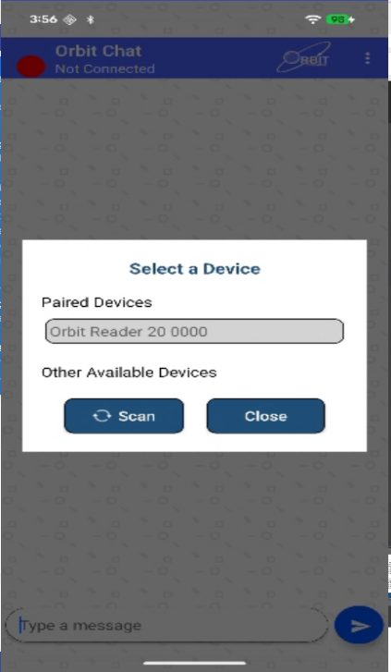
Figure 9
If your Orbit Reader unit is not already paired, it will not appear on the list. You can tap on the “Scan” button to initiate the first-time pairing. The list will show all the unpaired Orbit Reader units within range.

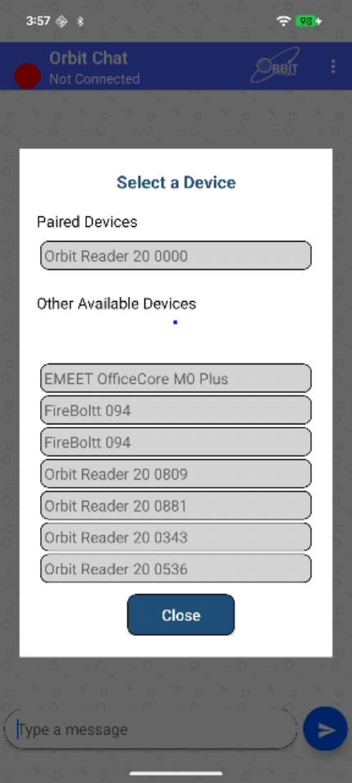
Figure 10
Click on the Bluetooth name of your Orbit Reader unit to initiate a connection. If that unit was not paired already, the Orbit Chat app will pop-up a message asking to pair with the new Orbit Reader unit. Tap on the “Pair” button on the pop-up message to establish the connection.

Upon successful connection between the Orbit Reader and the app, the Orbit Reader shall enter into chat mode automatically and will notify the user by blinking the cursor on the braille display.

To disconnect the Orbit Reader unit, tap on the “Disconnect” button from the Options menu. This will disconnect the unit and set the connection status to “Not Connected” in the title bar.

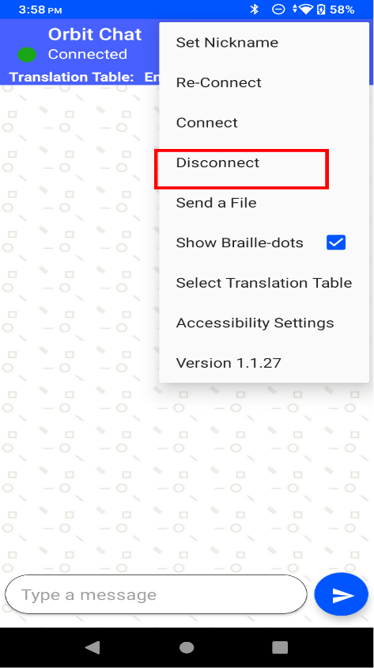
Figure 11

Using the File Transfer Feature
You can send or receive a file from the phone/tablet to the connected Orbit Reader unit and vice-versa using the Orbit Chat app. The system supports the transfer of TXT, BRF, BRA and BRL file types.

Note: File transfer from Orbit Chat to Orbit Reader and vice-versa is not permitted when the Orbit Reader’s Bluetooth broadcast mode is enabled.

Transfer a file from Orbit Chat to Orbit Reader
To send a file from Orbit Chat to the connected Orbit Reader unit, go to the Options menu à Send a file.
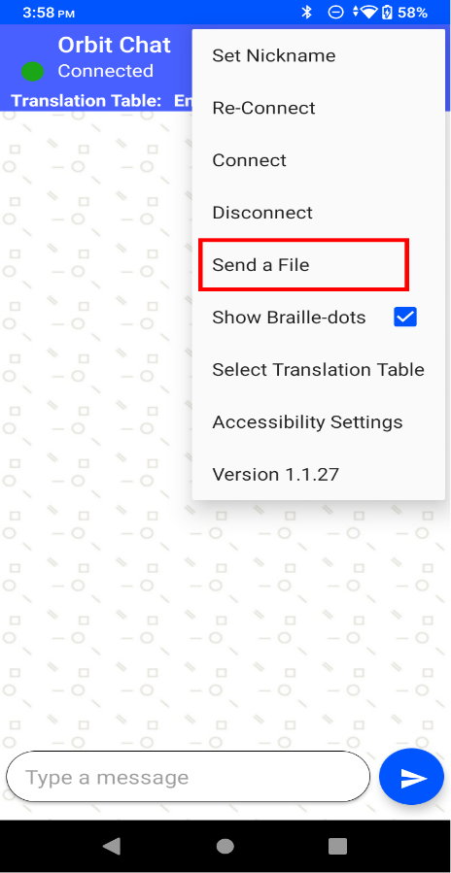
Figure 12

The Orbit Chat app will open the operating system’s default file browser as shown in the screenshots below.

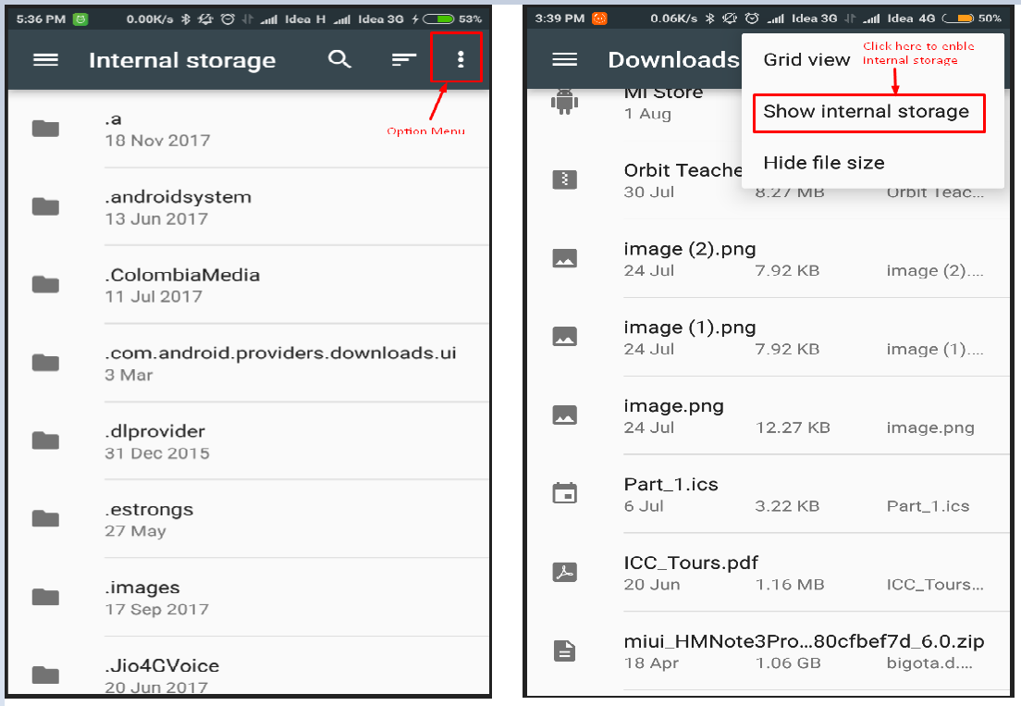
Figure 13

The file browser may not show the internal storage to a first-time user. To view internal storage in the file browser, go to the options menu (top right of the file browser) à “Show internal storage”.

After selecting a file, the Orbit Chat app opens a dialog box for confirmation. Tap “Yes” to send a file to the connected Orbit Reader unit. The Orbit Reader unit will display a confirmation message. Press the Dot 8 key on the Orbit Reader for receiving files from the Orbit Chat app or press the Dot 7 key to reject the request.

When the Orbit Reader is receiving a file from the Orbit Chat app, it does not enter sleep mode. However, if the file transfer request is rejected by pressing the Dot 7 key, the device can then be put into sleep mode manually or will enter auto sleep as expected.

The progress of the file transfer is shown by a progress bar and completion is indicated by a message saying “File transfer complete”.

Transfer a file from Orbit Reader to Orbit Chat
On the Orbit Reader, browse to a file from the file manager and press the “Space + Dots 1-3-6-7” key combination to send it to the connected phone/tablet. The Orbit Chat app will open a dialog for confirmation. Tap the “Yes” button for receiving the file from the Orbit Reader unit or tap on the “No” button to reject the request.

The completion of the file transfer is indicated by a message saying “Complete”.

Using the Broadcast feature

Broadcast mode
The Broadcast mode allows an Orbit Reader to be connected over Bluetooth with up to seven Android devices running the Orbit Chat app and send messages to all of the connected devices. This allows you to send a message to multiple Android devices simultaneously in a meeting for instance. This feature can be enabled from the Orbit Reader.

Turning on/off Broadcast mode on the Orbit Reader
The Broadcast feature can be turned on or off by using hotkeys "Space + B" or "Space + Dots 1 2 7”. The message “Broadcast On” or “Broadcast Off” is displayed to indicate the action.

Limitations of Broadcast mode
The following are some limitations of the Broadcast mode.
- All active Bluetooth connections are disconnected automatically when you switch between "Broadcast on" and "Broadcast off". You will have to initiate connections again from the application.
- File transfer is not allowed in Broadcast mode.
- Messages can be sent only from the Orbit Reader to connected devices and not vice-versa.

Chat History
The Orbit Chat application and the Orbit Reader unit automatically save the chat history.

Chat history on Orbit Reader
The Orbit Reader device saves the “ChatHistory.txt” file in the root directory of the SD Card.

Chat history on the Orbit Chat app
The Orbit Chat application saves “ChatHistory_Orbit Reader XXXX.txt” file in the Orbit Chat folder located in the internal storage of the Android device.
Here, XXXX in the file name stands for the serial number of the Orbit Reader unit.

Languages and translations
From the Orbit Reader or the Orbit Chat app, the user can type using any language listed in the menu “Select a translation table”. For proper translation, the appropriate language must be set or the messages might appear garbled.
Go to the Options Menu à Select Translation Table. A message box opens up with a list of languages supported by the current version of the application. Find the language you wish to use from the list and tap to select.

Upgrade Orbit Chat application
This section describes details of upgrading the Orbit Chat application on the Android tablet. If your Android tablet already has the latest version, you can skip this section for now and refer to it later when an upgrade is required.

Disable Launcher mode
In the bundle package, an app Launcher is enabled by default and it will only allow access to the Orbit Chat and Settings applications on the tablet. This is to avoid situations where the tablet is inadvertently switched to an app or mode from which it may be difficult to return to the Orbit Chat app. So in order to upgrade the application, you will need to disable the launcher by following the steps below.
- Swipe down from the top of the screen to go to your Android Tablet’s Settings -> Apps (or Apps & Notifications), scroll down and check for the “Default Apps”. Click & open the “Default Apps”.
- Once the “Default Apps” gets opened, you can be able to find the Home App.
- Click on the Home App and select the “QuickStep/Default Home/Launcher”.
- Once you select the “QuickStep/Default Home/Launcher” app then it will launch the android default launcher and set it as a default home launcher.

Download application
Download the Orbit Chat application from the link that is shared with you. You can either download directly in your Android Tablet or you can download on your computer and then save it to your Android Tablet. If the application is published to the play store, then you can directly download it from the play store also.

Copy the application to the tablet from a PC
If you have downloaded the application to your Android Tablet directly, you may skip this section.

Transfer APK file from Windows PC to Android Tablet
- Save Orbit Chat vX.X.X.X package from the mail/server to Windows PC.
- Connect Android Tablet with Windows PC via USB cable.
- As you connect the Android Tablet with PC, enable “Connect as File Transfer device (MTP)” that appears in the notification bar.
- Copy the Android application “Orbit Chat_X.X.X.X.apk” from the folder named “Orbit Chat - Android Application vX.X.X.X” package saved on your Windows PC and paste it in the internal storage of the Android Tablet.

Transfer APK file from Mac book to Android Tablet
- Save Orbit Chat vX.X.X.X package from the mail/server to your Mac book.
- Download and install “Android File Transfer” to your computer.
- Unlock your Android Tablet and connect with the Mac book via USB cable.
- As you connect the Android Tablet with the Mac book, enable “Connect as File Transfer device (MTP)” that appears in the notification bar.
- Once you connect the Android Tablet with the Mac book “Android File Transfer” will be opened automatically.
- Drag the Android application “Orbit Chat_X.X.X.X.apk” from the folder named “Orbit Chat - Android Application vX.X.X.X” package saved on your Mac book and drop it in the internal storage of the Android Tablet.

Install
- Open the File Manager application on your Android device and navigate to the location where you have pasted Orbit Chat_ vX.X.X.X.apk.
- Click on the Orbit Chat_vX.X.X.X.apk and install it. Once it gets done then it will notify on the screen. Open the application.

Permissions
While installing/upgrading the Orbit Chat app, the Android system will ask you to grant several permissions to the application. Orbit Chat needs the following permissions to run:

- Access Bluetooth Settings: This permission is required to allow Orbit Chat to turn on Bluetooth if it is turned off.
- Approximate Location: This Permission is required because Android relies on the location services to retrieve the identity of nearby Bluetooth devices.
- Storage: The application needs permission to create a log file. The application will not modify or delete any other storage contents.

Note: If you deny any of these permissions, the application will not work properly.

Enable Launcher mode
To enable the launcher, do the following steps:
- Go into your Android Tablet’s Settings -> Apps (or Apps & Notifications), scroll down and check for the “Default Apps”. Click & open the “Default Apps”.
- Once the “Default Apps” gets opened, you can be able to find the Home App.
- Click on the Home App and select the “Orbit Chat”.
- Once you select the “Orbit Chat” app then it will launch the app and set it as a default home launcher.

Enable/Disable TalkBack

Enable Talkback
- Open your device settings
- Navigate to Additional Settings and tap it.
- Navigate to Accessibility and tap it
- Navigate to TalkBack and tap it.
- Navigate to TalkBack and Enable it

Disable TalkBack
- Open your device settings
- Navigate to Additional Settings and tap it.
- Navigate to Accessibility and tap it
- Navigate to TalkBack and tap it.
- Navigate to TalkBack and Disable it

Enable/Disable Talkback using shortcut
- Press the Volume Up and Volume Down keys together

Known Issues and Limitations
- If the connected Orbit Reader unit is reset, the notification of disconnection on the Orbit Chat app might gets delayed. As we are using Bluetooth connection due to which it gets delayed.
- Sometimes the Orbit Reader may not connect automatically to Orbit Chat upon powering on the Orbit Reader device. This happens because TalkBack (or another screen reader) gets connected to Orbit Reader first. In this situation, the following steps will resolve the issue if TalkBack is on.
- Turn off TalkBack:
  - Open your device settings
  - Navigate to Additional Settings and tap it.
  - Navigate to Accessibility and tap it
  - Navigate to TalkBack and tap it.
  - Navigate to TalkBack and Disable it
- Reset the Orbit Reader by pressing the lower right panning key and the Dot 8 key and then turn the unit ON.
- Connect the Orbit Reader unit to Orbit Chat by tapping on the “Connect” item from the Options menu.
- The file browser in Orbit Chat does not support browsing directly from Google Drive. You need to first copy the file to be transferred to internal storage and then transfer it to the Orbit Reader.
- File transfer is not supported from the Download folder. You need to first copy the file to be transferred to the internal storage and then transfer it to the Orbit Reader.
- If you disconnect from Orbit Chat while the chat mode is active on the Orbit Reader unit, it may sometimes show the error message “SD error 35”. Discard the message by pressing the Dot 7 key on the Orbit Reader.
- Orbit Chat can be connected to only one Orbit Reader at a time.
- If Orbit Chat is running in the background, no notification is generated for received messages.
- All active Bluetooth connections are disconnected automatically when you switch between "Broadcast on" and "Broadcast off". You will have to initiate the connections again from the app.
- File transfer is not allowed in Broadcast mode. Turn off broadcast mode to transfer files.
- With TalkBack enabled, while the Orbit Reader user is typing, focus in the Orbit Chat app will shift to the top of the message instead of the message typing box.
- When the Orbit Reader is connected to the Orbit Chat app, it does not enter sleep mode when the power key is pressed.

Troubleshooting

Unable to pair Orbit Reader unit with Android Tablet
- Reboot the Android tablet, reset the Orbit Reader unit and try again.

Not able to connect the Orbit Reader unit with Android Tablet
- Make sure you are pressing the Dot 8 key to accept the connection request within 30 seconds.
- If TalkBack is running on the Android tablet, disable TalkBack and try again
- Reset the Orbit Reader unit and try again.
- Make sure Orbit Reader is not connected to any other PC or phone.
- Unpair the Orbit Reader unit from all the paired PCs and Phones and try again.

Not able to send a message from Orbit Reader
- Make sure you have enabled chat mode on the Orbit Reader unit and you are not in the file editor. You cannot send a message to Orbit Chat from the file editor. You can enable chat mode by pressing the “Dots 4-6 + select” key combination.
- Type a message on the Orbit Reader unit and press the Dot 8 key to send a message to the Orbit Chat app.

The received messages appear as non-English text in Orbit Chat
- Make sure that the language typed on the Orbit Reader and the selected Translation Table language are matched.

Not able to send a message from Orbit Chat
- Make sure you have not included any emoji in the message.
- Make sure the Orbit Reader unit is connected with Orbit Chat.

TalkBack is getting connected with Orbit Reader instead of connect with Orbit Chat.
- Turn off the TalkBack by following the steps below
  - Open your device settings
  - Navigate to Additional Settings and tap it.
  - Navigate to Accessibility and tap it
  - Navigate to TalkBack and tap it.
  - Navigate to TalkBack and Disable it
- Reset the Orbit Reader by pressing the lower right panning key and the Dot 8 key and then turn the unit ON.
- Connect the Orbit Reader unit to Orbit Chat by tapping on the “Connect” item from the Options menu.

