 | Proprietary  Information

Orbit Chat
User Guide

15th July 2026
Version 1.12
Contents
1 Introduction 3
2 How Orbit Chat is used 3
3 Installing Orbit Chat application 3
3.1 Download application 3
3.2 Permissions 3
4 The User Interface for the Orbit Chat app 4
5 Connect with Orbit Reader unit 7
6 Using the Chat Features 9
6.1 Configure Nickname of the User 9
6.2 Initiating Communication 10
6.3 Send/Receive messages from Orbit Chat to Orbit Reader 12
6.4 Send/Receive messages from Orbit Reader to Orbit Chat 13
6.5 Closing the connection 13
6.6 Resuming the connection automatically 13
7 Using the File Transfer Feature 14
7.1 Transfer a file from Orbit Chat to Orbit Reader 14
7.2 Transfer a file from Orbit Reader to Orbit Chat 15
8 Using the Broadcast feature 16
8.1 Broadcast mode 16
8.2 Turning on/off Broadcast mode on the Orbit Reader 16
8.3 Limitations of Broadcast mode 16
9 Chat History 16
9.1 Chat history on Orbit Reader 16
9.2 Chat history on the Orbit Chat app 16
10 Languages and translations 16
11 Turn on/off Talkback 17
11.1 Turn on Talkback in your device settings 17
11.2 Turn off Talkback in your device settings 17
11.3 Turn On/Off Talkback using shortcut key 17
12 Known Issues and Limitations 17
13 Troubleshoot 18
13.1 Unable to pair Orbit Reader unit with Android device 18
13.2 Not able to connect the Orbit Reader unit with Android device 18
13.3 Not able to send a message from Orbit Reader 18
13.4 The received messages appear as non-English text in Orbit Chat 19
13.5 Not able to send a message from Orbit Chat 19

Introduction
Orbit Chat™ is an Android application that enables deaf-blind users to communicate with other people at public places or at home using their Orbit Reader.

This manual will first guide you through the installation of the Orbit Chat application on your Android phone/tablet and then guide you through the basic usage of the chat feature.

Notes:
- This document also includes pictures of the Android application user interface. These are for illustrative purposes only. The actual user interface may vary
- This application works on Android version 4.4 or higher.

How Orbit Chat is used
Connect your Orbit Reader and the Orbit Chat application over Bluetooth. Once it is connected, you can start sending messages from the Android application to Orbit Reader. Any message that you send from the application is shown on the braille display of connected Orbit Reader. You can reply or send a new message from your Orbit Reader to the Android application. It will be shown on the screen of your Android phone.

Installing Orbit Chat application
This section captures details of installing the application on Android device. This section is useful for the person providing assistance to the deaf and blind user setting up the system. If you have purchased the bundle, then your Android tablet comes pre-installed and configured. In that case you can skip this section.

Download application
Download and install the Orbit Chat application (apk) file from the Playstore at https://play.google.com/store/apps/details?id=com.orbitchat

Permissions
While installing the Orbit Chat, the Android system will ask you to grant several permissions to the application. Orbit Chat needs the following permissions to run its functionalities:

- Access Bluetooth Settings: This permission is required so that if the Bluetooth is turned off at the time of using the Orbit Chat, it can request to turn on the Bluetooth.
- Approximate Location: This Permission is required because Android relies on the location services to retrieve the identity of the nearby Bluetooth devices.
- Storage: The application needs permission to create a log file. The application will not modify or delete any other storage contents.

Note: On denying any of the above permissions, the application will not work properly.

The User Interface for the Orbit Chat app
When the Orbit Chat app is first run, a Welcome screen pops up, informing a sighted or blind user about the purpose of the app. The screenshot below shows the Welcome screen.

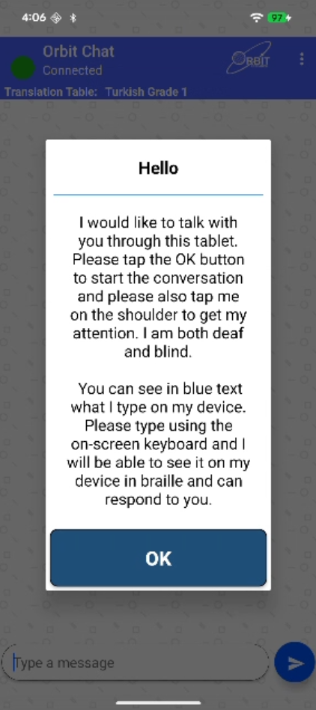
Figure 1
Once the Welcome screen is dismissed by tapping the “OK” button, the start-up screen is displayed and looks like the screenshot below.

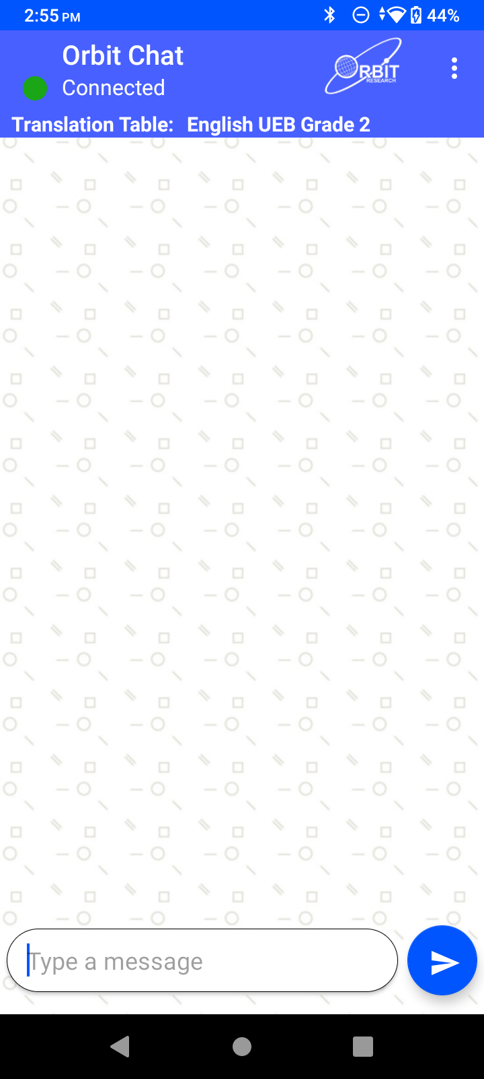
Figure 2
At the very top is a title bar. It displays the application name along with the connection status.

On the top right corner of the title bar, is an “Option” menu (indicated by the three vertical dots). Tapping on this displays the following options:

- Change Nickname – Tap on this to configure a nickname for the person using the phone/ tablet. The nickname appears at the beginning of each message received and displayed on the Orbit Reader unit.
- Reconnect – This initiates the connection process with the last connected Orbit Reader unit.
- Connect – This initiates the connection process with the Orbit Reader unit.
- Disconnect - This disconnects the currently connected Orbit Reader unit.
- Send a file – This allows browsing for and sending a file to the connected Orbit Reader unit
- Show Braille-dots – By default, received messages are shown on the app as English text and 8-dot Braille symbols. You can disable the Braille output on the app using this setting.
- Select Translation Table – To select the braille to text translation table for the language in use.
- Accessibility Settings – To open the Accessibility Setting page of the phone/ tablet.
- Version – To check the app’s version number.

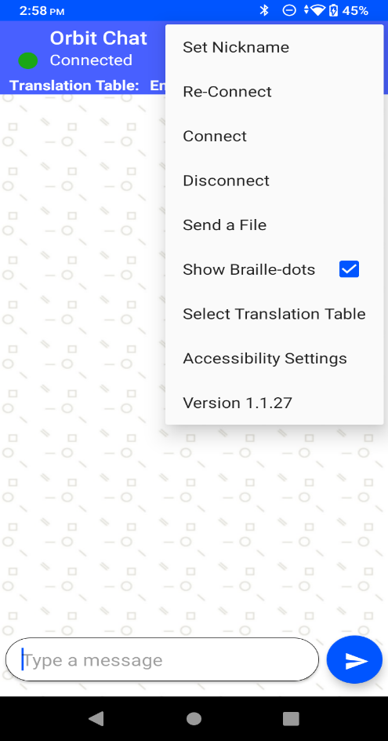
Figure 3
The Orbit Reader unit can be localized to any language in addition to the default language.

At the top of the home screen of the Orbit Chat app is a field showing the configured Translation Table language. You should make sure that the language typed on the Orbit Reader and the selected Translation Table language are matched. The messages may appear garbled otherwise. When no unit is connected, this field is hidden.

Below the Translation Table language, is a display window that shows messages in chat style. The messages sent by you from the phone/ tablet will appear on the right side of the window, and the received messages will appear on the left side of the window. When no unit is connected, nothing will be displayed.

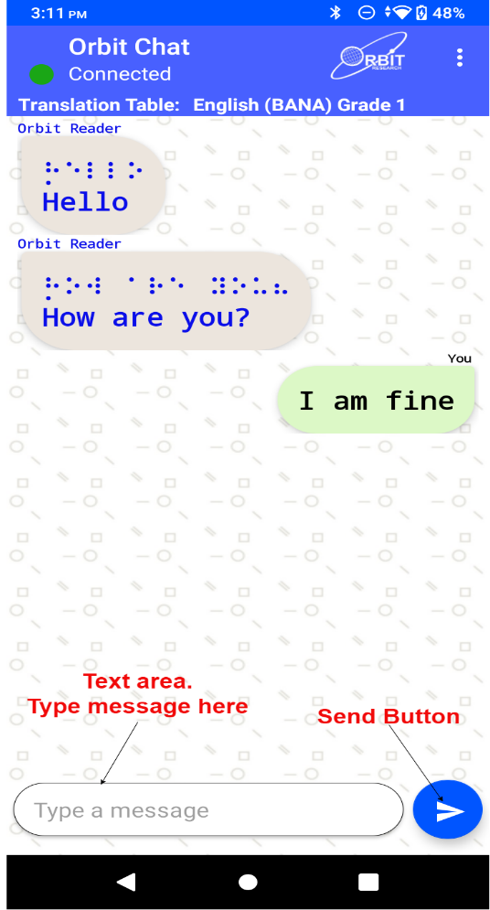
Figure 4
At the bottom is a text field where you can type the messages and a “send” button to send the message to the connected Orbit Reader unit.

Connect with Orbit Reader unit
Connecting Orbit Reader with Orbit Chat may require assistance from the sighted person. But this is a one-time process. Once the connection is established, deaf-blind users can use it without any assistance required.

To connect to an Orbit Reader unit, go to the Options menu à Connect. The Orbit Chat opens a new page showing a list of already paired devices available for the connection as shown in the screenshot below. If your Orbit Reader unit’s Bluetooth name appears on the listed devices, tap it to initiate the connection.

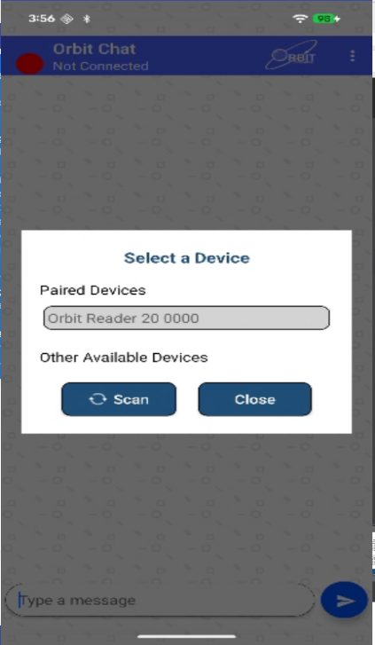
Figure 5
If your Orbit Reader unit is not already paired, it will not appear on the list. You can tap on the “Scan for devices” button to initiate the first-time pairing. The list will show all the unpaired Orbit Reader units within range.

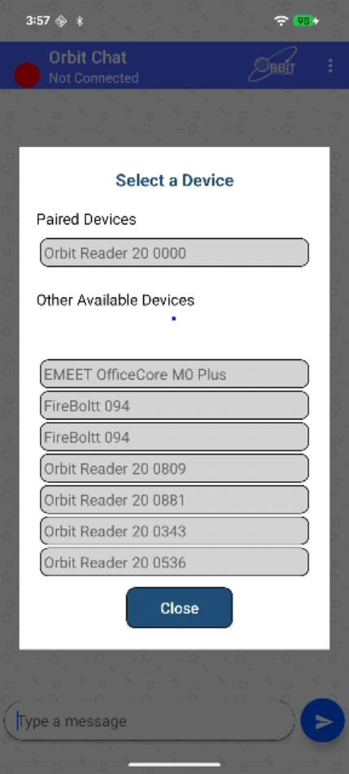
Figure 6
Click on the Bluetooth name of your Orbit Reader unit to initiate a connection. If that unit was not paired already, the Orbit Chat app will pop-up a message asking to pair with the new Orbit Reader unit. Tap on the “Pair” button on the pop-up message to establish the connection.

Upon successful connection between the Orbit Reader and the app, the Orbit Reader shall enter into chat mode automatically and will notify the user by blinking the cursor on the braille display.

To disconnect the Orbit Reader unit, tap on the “Disconnect” button from the Options menu. This will disconnect the unit and set the connection status to “Not Connected” in the title bar.

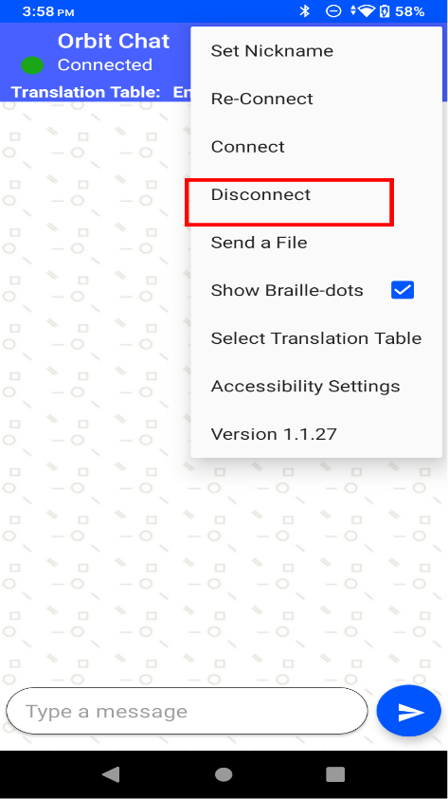
Figure 7

Using the Chat Features
The Orbit Chat provides several features. These become available once the app is connected to an Orbit Reader and are described in the following sections.

Configure Nickname of the User
The nickname is a name that appears along with your messages on the connected Orbit Reader unit’s braille display. This helps the person operating the Orbit Reader unit to know the sender’s name.

To set the Nickname, go to the Options menu à Set Nickname. Orbit Chat opens a dialog box for configuring the nickname as shown in the picture below.

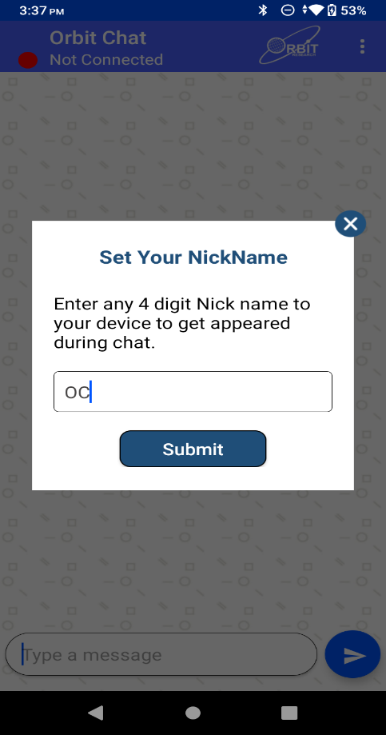
Figure 8

Enter a nickname in the text area and tap on the “Set Nickname” button to set your Nickname. If you do not want to set a nickname then left the nickname as blank in the nickname text area and tap on the “Set Nickname” button.

The length of the nickname cannot be more than 4 letters.

Initiating Communication
When a deafblind person wishes to initiate communicate, they will unlock the Android phone/ tablet and give it to the person with whom they wish to communicate. When the other person looks at the phone screen, they will be greeted with a welcome note as shown in the screenshot below which says, “Hello, I would like to talk with you through this tablet. Please tap the OK button to start the conversation and please also tap me on the shoulder to get my attention. I am both deaf and blind. You can see in black text what I type on my device. Please type using the on-screen keyboard and I will be able to see it on my device in braille and can respond to you.”
Once the person taps “OK” on the phone/ tablet, they will see the home screen and chat can be initiated.
Figure 9

If for some reason, Orbit Chat is not connected to the Orbit Reader unit, the following message appears. In this case, a connection has to be established manually as described in the section “Connect with Orbit Reader unit from Orbit Chat “.
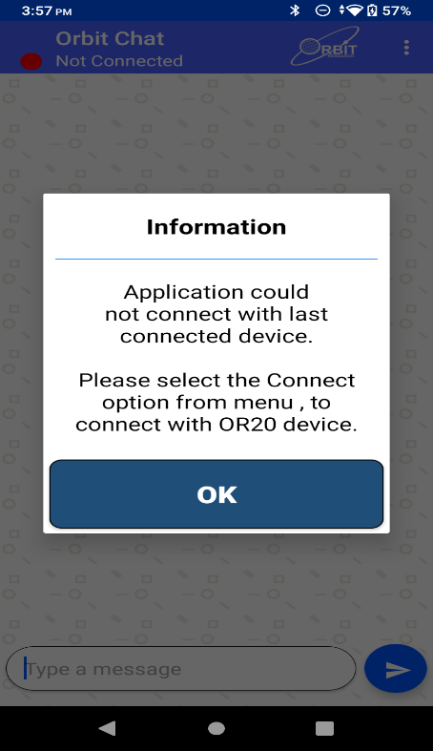
Figure 10

Send/Receive messages from Orbit Chat to Orbit Reader
A chat session can be initiated either from the Orbit Chat app or from the Orbit Reader. To initiate a chat session from the Orbit Chat app, type your message in the message box at the bottom of the screen and tap the “Send” button. The messages sent by you appear on the right side of the chat window. When you receive a reply from the Orbit Reader unit, it appears on the left side of the chat window. A maximum of 1000 characters are allowed in a single message.

Note:
- The Orbit Chat user cannot type a message while the Orbit Reader user is typing a message. In this case, the application will not allow typing and will display the message “Orbit Reader typing”. In case, Orbit Reader user does not type for the 10 seconds then time out will occur and the application will allow typing and display the message “Type a message”.
- When Orbit Reader is in standby, the Orbit Chat app will displays the message “Orbit Reader in Standby mode...” and will not allow the user to type any message. Tap on power on key to exit the standby status of Orbit Reader.
- You will not able to send any message from Orbit Chat to the Orbit Reader in Broadcast mode. The details of Broadcast mode are covered in a later section of this document.

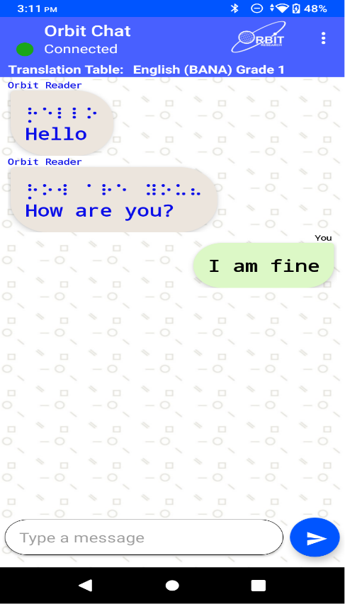
Figure 11

Send/Receive messages from Orbit Reader to Orbit Chat
To initiate a chat session from the Orbit Reader, enable Chat mode by pressing “Select + Dots 4-6”. This opens an editor field with a blinking cursor (dots 7 and 8).

You can type your message and press dot 8 to send the message to the Orbit Chat app. A maximum of 1000 characters are allowed in a single message.

When you receive a message on from the Orbit Chat app, it is displayed on your Orbit Reader’s braille display. Press the Dot 8 key to reply to the received message or press the Dot 7 key to discard it. Pressing the Dot 7 key takes you back to what you were doing before the notification appeared on your display.

To exit chat mode press “Select + Dots 4-6 again. This takes you back to the previous operating mode on the Orbit Reader unit.

Notes:
- The Orbit Reader user cannot type a message while the Orbit Chat user is typing a message. In this case, the Orbit Reader will not allow typing and will display the message “[Nickname]: Typing.”. In case Orbit Chat user does not type for the 10 seconds then time out will occur and Orbit Reader will allow typing and display the typed message with a blinking cursor.”
- When Android phone/ tablet is in standby, Orbit Reader will display the message “Device locked” and when it exits from the standby, Orbit Reader will display the message “Device unlocked”. Press Dot 7 key to discard the message.
- When the Android phone/ tablet is in Standby Mode (screen lock), if the Orbit Reader user sends a message, the phone/ tablet will wake up automatically but needs to be unlocked by swiping up on the phone/ tablet’s screen.

Closing the connection
The connection to the Orbit Reader is closed automatically when you turn off or reset the Orbit Reader.
Note that the Orbit Chat app and the Orbit Reader unit remain connected when you put the phone/tablet on standby (screen lock) or the Orbit Reader in sleep mode.
To manually disconnect the app from the Orbit Reader using Orbit Reader keypad, press SPACE + D (Dots 1 4 5 7). To manually disconnect from the Orbit Chat app, go to the Options menu and tap on “Disconnect”.

Resuming the connection automatically
The Orbit Reader reconnects to the last connected phone/tablet when it is turned on, the phone/tablet’s Bluetooth feature is on and the Orbit Chat app is running.
If you have locked the phone/tablet’s screen while app was running, any activity on the Orbit Reader wakes the phone/tablet and re-connects.

To connect manually, follow the steps described in the section “Connect with Orbit Reader unit from Orbit Chat “

Using the File Transfer Feature
You can send or receive a file from the phone/tablet to the connected Orbit Reader unit and vice-versa using the Orbit Chat app. The system supports the transfer of TXT, BRF, BRA and BRL file types.

Note: File transfer from Orbit Chat to Orbit Reader and vice-versa is not permitted when the Orbit Reader’s Bluetooth broadcast mode is enabled.

Transfer a file from Orbit Chat to Orbit Reader
To send a file from Orbit Chat to the connected Orbit Reader unit, go to the Options menu à Send a file.
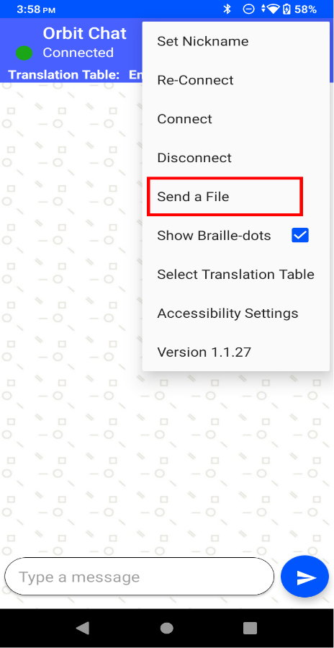
Figure 12

The Orbit Chat app will open the operating system’s default file browser as shown in the screenshots below.

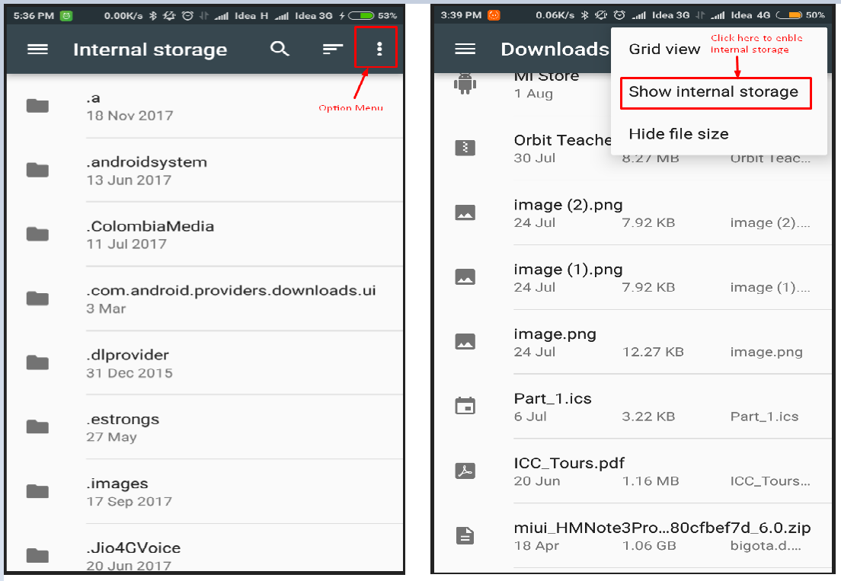
Figure 13

The file browser may not show the internal storage to a first-time user. To view internal storage in the file browser, go to the options menu (top right of the file browser) à “Show internal storage”.

After selecting a file, the Orbit Chat app opens a dialog box for confirmation. Tap “Yes” to send a file to the connected Orbit Reader unit. The Orbit Reader unit will display a confirmation message. Press the Dot 8 key on the Orbit Reader for receiving files from the Orbit Chat app or press the Dot 7 key to reject the request.

The progress of the file transfer is shown by a progress bar and completion is indicated by a message saying “File transfer complete”.

Transfer a file from Orbit Reader to Orbit Chat
On the Orbit Reader, browse to a file from the file manager and press the “Space + Dots 1-3-6-7” key combination to send it to the connected phone/tablet. The Orbit Chat app will open a dialog for confirmation. Tap the “Yes” button for receiving the file from the Orbit Reader unit or tap on the “No” button to reject the request.

The completion of the file transfer is indicated by a message saying “Complete”.

Using the Broadcast feature

Broadcast mode
The Broadcast mode allows an Orbit Reader to be connected over Bluetooth with up to seven Android devices running the Orbit Chat app and send messages to all of the connected devices. This allows you to send a message to multiple Android devices simultaneously in a meeting for instance. This feature can be enabled from the Orbit Reader.

Turning on/off Broadcast mode on the Orbit Reader
The Broadcast feature can be turned on or off by using hotkeys "Space + B" or "Space + Dots 1 2 7”. The message “Broadcast On” or “Broadcast Off” is displayed to indicate the action.

Limitations of Broadcast mode
The following are some limitations of the Broadcast mode.
- All active Bluetooth connections are disconnected automatically when you switch between "Broadcast on" and "Broadcast off". You will have to initiate connections again from the application.
- File transfer is not allowed in Broadcast mode.
- Messages can be sent only from the Orbit Reader to connected devices and not vice-versa.

Chat History
The Orbit Chat application and the Orbit Reader unit automatically save the chat history.

Chat history on Orbit Reader
The Orbit Reader device saves the “ChatHistory.txt” file in the root directory of the SD Card.

Chat history on the Orbit Chat app
The Orbit Chat application saves “Chat History Orbit Reader XXXX.txt” file in the Orbit Chat folder located in the internal storage of the Android device.
Here, XXXX in the file name stands for the serial number of the Orbit Reader unit.

Languages and translations
From the Orbit Reader or the Orbit Chat app, the user can type using any language listed in the menu “Select a translation table”. For proper translation, the appropriate language must be set or the messages might appear garbled.
Go to the Options Menu à Select Translation Table. A message box opens up with a list of languages supported by the current version of the application. Find the language you wish to use from the list and tap to select.

Turn on/off Talkback

Turn on Talkback in your device settings
The steps below require sighted assistance.
- Open your device's Settings app
- Open Accessibility, then Talkback.
- Turn on Talkback.
- In the confirmation dialog, tap OK.

Turn off Talkback in your device settings
- Open your device's Settings app
- Open Accessibility, then Talkback.
- Turn off Talkback.

Turn On/Off Talkback using shortcut key
If your device has the accessibility shortcut turned on, simply press both volume keys for 3 seconds.
If you try this option and it doesn't work, follow the steps below to turn on the accessibility shortcut.
- Open your device's Settings app
- Tap Accessibility, then Volume key shortcut.
- On some devices, this setting is called Accessibility shortcut.
- At the top, turn on Volume key shortcut.
- Optional: To change which accessibility service the shortcut controls, tap Shortcut service.
- If you don't see this option, refer to the steps for earlier versions below.
- Optional: Change whether the shortcut works from the lock screen
For more details about Talkback, please read the guide from Google available at:
https://support.google.com/accessibility/android/answer/6283677?hl=en

Known Issues and Limitations
- If the connected Orbit Reader unit is reset, the notification of disconnection on the Orbit Chat app is delayed and will appear after 10 to 20 seconds.
- The file browser in Orbit Chat does not support browsing directly from Google Drive. You need to first copy the file to be transferred to internal storage and then transfer it to the Orbit Reader.
- File transfer is not supported from the Download folder. You need to first copy the file to be transferred to the internal storage and then transfer it to the Orbit Reader.
- If you disconnect from Orbit Chat while the chat mode is active on the Orbit Reader unit, it may sometimes show the error message “SD error 35”. Discard the message by pressing the Dot 7 key on the Orbit Reader.
- Orbit Chat can be connected to only one Orbit Reader at a time.
- If Orbit Chat is running in the background, no notification is generated for received messages.
- All active Bluetooth connections are disconnected automatically when you switch between "Broadcast on" and "Broadcast off". You will have to initiate the connections again from the app.
- File transfer is not allowed in Broadcast mode. Turn off broadcast mode to transfer files.
- When taking the device out of range, display is not updated and cannot reconnect when the device is back in range. To resume the connection automatically, turn off the Orbit Reader device and turn it back on again.

Troubleshoot

Unable to pair Orbit Reader unit with Android device
Reboot the Android device, reset the Orbit Reader unit and try again.

Not able to connect the Orbit Reader unit with Android device
- Make sure you are pressing the Dot 8 key to accept the connection request within 30 seconds.
- Reset the Orbit Reader unit and try again.
- Make sure Orbit Reader is not connected to any other PC or phone.
- Unpair the Orbit Reader unit from all the paired PCs and Phones and try again.

Not able to send a message from Orbit Reader
- Make sure you have enabled chat mode on the Orbit Reader unit and you are not in the file editor. You cannot send a message to Orbit Chat from the file editor. You can enable chat mode by pressing the “Dots 4-6 + select” key combination.
- Type a message on the Orbit Reader unit and press the Dot 8 key to send a message to the Orbit Chat app.

The received messages appear as non-English text in Orbit Chat
- Make sure that the language typed on the Orbit Reader and the selected Translation Table language are matched.

Not able to send a message from Orbit Chat
- Make sure you have not included any emoji in the message.
- Make sure the Orbit Reader unit is connected with Orbit Chat.

