

Runa TTS for Windows — User Manual

09th October 2026
Version 1.13

Runa TTS for Windows — User Manual
Contents
- How to use this manual
  - Conventions
- Part 1 — Getting started
  - 1. What Runa TTS is
  - 2. Quick start
  - 3. Installing Runa TTS
  - 4. Activating your license
  - 5. Installing voices
  - 6. Choosing Runa in your screen reader
- Part 2 — The Control Panel
  - 7. Control Panel basics
  - 8. Voice Profiles
  - 9. Smart Switch
  - 10. Text Processing
  - 11. User Dictionary
  - 12. Advanced
  - 13. General and About
- Part 3 — Reference
  - 14. Everyday setups
  - 15. Troubleshooting
  - 16. Quick reference
Version 2.0 · AccessMind LLC
Runa TTS is a speech system for Windows. It provides voices to JAWS, NVDA, and any program that supports Microsoft SAPI 5, and it adds features those programs do not have on their own — most importantly, the ability to switch voices automatically when your text changes writing system.
This manual covers installing Runa, activating it, adding voices, selecting it in your screen reader, and every setting in the Runa TTS Control Panel.
How to use this manual
If you are setting Runa up for yourself, read Quick start, then come back to the chapters that interest you. Runa works out of the box after the quick start; everything after it is refinement.
If you are installing Runa for someone else, read Installing Runa TTS and Activating your license. Those two chapters are the whole of the administrator's job. Hand the user the rest.
Conventions
- Names of buttons, check boxes, tabs, and lists appear in bold and match exactly what your screen reader announces — for example, Install selected.
- Keystrokes appear as Alt+E. Where a control has an underlined letter in its label, that letter is its access key: Alt plus that letter activates it from anywhere on the page.
- Screenshots are provided for readers who want them. Every screenshot repeats information that is already in the surrounding text, so nothing is lost if you do not see them.
- File locations are written with the Windows variables that stand for them, for example %APPDATA%. You can type such a path directly into File Explorer's address bar or the Run dialog (Windows+R).

Part 1 — Getting started
1. What Runa TTS is
Runa TTS sits between your screen reader and the voices that actually speak. It gives you:
- Two voice families in one place. Runa supports ReadSpeaker voices and Cerence Vocalizer voices. You choose voices by how they sound and what language they speak; which family a voice belongs to matters only in a few places, and this manual points those out.
- Automatic voice switching. Runa's Smart Switch reads the characters in your text and sends each part to the voice you chose for that writing system — Hebrew to a Hebrew voice, Latin to an English voice, and so on, inside a single sentence.
- One set of settings for every program. Pronunciation replacements, punctuation handling, and capital-letter announcements are configured once and apply to JAWS, NVDA, and SAPI 5 programs alike.
- Voice management. Runa downloads, verifies, installs, and removes voices itself. No separate voice installer, and no administrator rights needed after Runa is installed.
Everything is configured in one program: the Runa TTS Control Panel.
What decides which voices you can use
Your license does. Some licenses include ReadSpeaker voices, some include Vocalizer voices, and some include both. Voices outside your license are not offered for download. If you expected a voice family and do not see it, the license is the first thing to check — see Activating your license.
2. Quick start
This is the shortest path from a new installation to working speech. It assumes someone has already run the Runa installer; if not, start at Installing Runa TTS.
1. Open the Control Panel. Press Windows, type RunaTTS control panel, and press Enter. The shortcut is in the RunaTTS folder of the Start menu.
2. Activate your license. Go to the License tab (Ctrl+Tab moves between tabs). If it says License status: Not activated, press the Activate... button and follow the AccessMind Runtime window that opens. When it closes, Runa refreshes by itself.
3. Install a voice. Go to the Manage Voices tab. Set Language filter to your language, move down the Voices list, press Space to check the voice you want, then press the Install selected button. Wait for the download to finish.
4. Restart your screen reader. This matters. A running screen reader does not notice new voices until it restarts.
5. Select Runa in your screen reader. You do not need to create anything first — Runa ships with a ready-made profile called Runa Smart Switch, and it is already published to your screen reader as a voice named Runa Smart Switch (Runa Profile).
- JAWS: press Insert+Ctrl+S and choose the RunaTTS voice profile.
- NVDA: press NVDA+Ctrl+S, choose Runa TTS, then pick Runa Smart Switch (Runa Profile) as the voice.
- Other SAPI 5 programs: open the program's voice settings and choose Runa Smart Switch (Runa Profile).
That is a working installation. If you read more than one writing system, install a voice for each and then read Smart Switch — the built-in profile is already switched on and only needs you to name the voices.
3. Installing Runa TTS
This chapter is written for whoever runs the installer. It can be done entirely from the keyboard, and the installer works with a screen reader running.
Before you start
- You need administrator rights on the computer.
- An internet connection is needed to activate the license and to download voices. The installation itself does not require one.
- You may leave your screen reader running. You will restart it at the end.
Running the installer
- Start the Runa TTS setup program supplied by AccessMind or your distributor.
- Approve the Windows security prompt.
- Work through the wizard pages. The defaults are correct for a normal installation.
- On the JAWS Driver Installation page, setup lists every JAWS version it found, as "JAWS version - folder", each with a check box. All are checked. Leave checked the versions you actually use; clear any you do not. If no JAWS is installed, this page does not appear.
- Let setup finish, then restart JAWS, NVDA, or any SAPI 5 program that was open.
What setup installs
- The Runa speech runtime and the Runa TTS Control Panel.
- The SAPI 5 voice provider, registered for both 64-bit and 32-bit programs.
- A JAWS driver for each JAWS version you selected, plus a ready-made JAWS voice profile and a Runa symbol file.
- The NVDA add-on file, placed in the Runa program folder ready to install.
- The AccessMind Runtime, which handles licensing.
- The Microsoft Visual C++ 2013 redistributable, if this computer does not already have it. ReadSpeaker voices need it. Setup lists it on its Ready page, installs it silently, and skips it when it is already present. It is included inside the setup file, so this works on computers with no internet connection.
What you get in the Start menu
Setup creates a RunaTTS folder containing:
Shortcut | What it does
RunaTTS control panel | Opens the Control Panel. This is the one you will use.
Install NVDA add-on | Installs the Runa add-on into NVDA. See NVDA.
Repair SAPI5 integration | Re-registers the SAPI 5 voice provider. Only needed if Runa stops appearing in SAPI 5 programs. Installing or removing voices never requires it.
Uninstall RunaTTS | Removes Runa TTS.
Upgrading
Run the newer installer over the existing installation. Your voices, profiles, dictionary entries, and license are preserved. Restart your screen reader afterwards so it loads the new components.
Repairing
If the Control Panel reports that AccessMind Runtime is missing, or Runa stops appearing in your programs, run the installer again over the existing installation. If only SAPI 5 programs are affected, try the Repair SAPI5 integration shortcut first — it is much quicker.
Uninstalling
Use Installed apps in Windows Settings, or the Uninstall RunaTTS shortcut.
If you intend to use this license on a different computer, remove the activation before uninstalling — open the Control Panel, go to License, and press Remove activation.... An activation left behind on a machine you no longer use may prevent you from activating elsewhere.
4. Activating your license
Runa's licensing is handled by a separate AccessMind component called the AccessMind Runtime, shared with other AccessMind products. The Control Panel shows your status and launches that Runtime when you want to change something.
Open the Control Panel and go to the License tab.
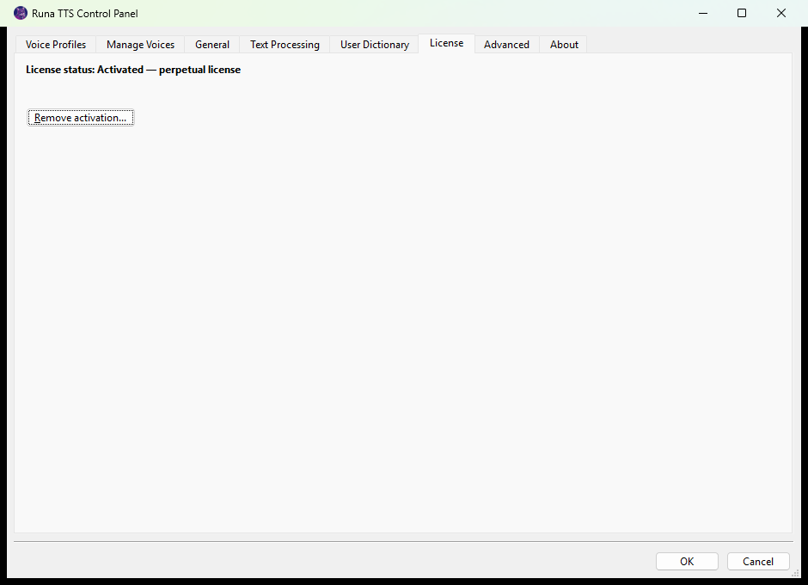
Reading the status line
The first line on the page tells you where you stand:
Status | Meaning
License status: Activated | Runa is licensed.
License status: Activated — perpetual license | Licensed with no expiry date.
License status: Activated — n days remaining | Licensed until the stated number of days runs out.
License status: Trial or Trial — n days remaining | Running on a trial.
License status: Not activated | No license. See If Runa is not activated below.
License status: unavailable | Runa could not read the license file. Speech continues under a fail-safe policy. Repair the installation.
If the status ends with (activated offline), this machine was activated without an internet connection. That is normal and needs no action.
One button, two labels
There is a single button below the status line, and its label depends on your state:
- When Runa is not licensed, it reads Activate....
- When Runa is licensed, it reads Remove activation....
So if you are looking for "Activate" and hear "Remove activation", Runa is already activated and there is nothing to do.
Activating
- Press Activate.... The AccessMind Runtime licensing window opens as a separate window — move to it with Alt+Tab if your screen reader does not follow automatically.
- Enter the details for your license and complete the steps shown.
- When the window closes, you return to the Control Panel and Runa refreshes on its own.
The Control Panel stays usable while the licensing window is open; the button is disabled until you finish.
If your license supports offline activation, the option appears inside the licensing window. If it does not appear, your license does not include it — contact whoever supplied the license.
Removing an activation
Press Remove activation... and follow the prompts. Do this only when you mean to stop using Runa on this computer, such as before moving the license to another machine.
If Runa is not activated
Runa does not go silent the moment it finds no license. It gives you a grace period, and the License tab tells you how long is left:
Runa TTS is in its unlicensed grace period. Normal speech remains available for approximately n more minutes.
When that runs out, speech is reduced to an activation reminder until you activate.
Voice management is restricted immediately, though. Without a license the Manage Voices tab reports:
No voice engines are available because Runa TTS is not activated. Activate a license on the License tab to manage voices.
If you have activated but Runa still says otherwise
Close and reopen the Control Panel, then restart your screen reader. If it persists, see Troubleshooting.
5. Installing voices
Voices are downloaded and installed from the Manage Voices tab. You do not need administrator rights, and you do not need to re-register anything afterwards.
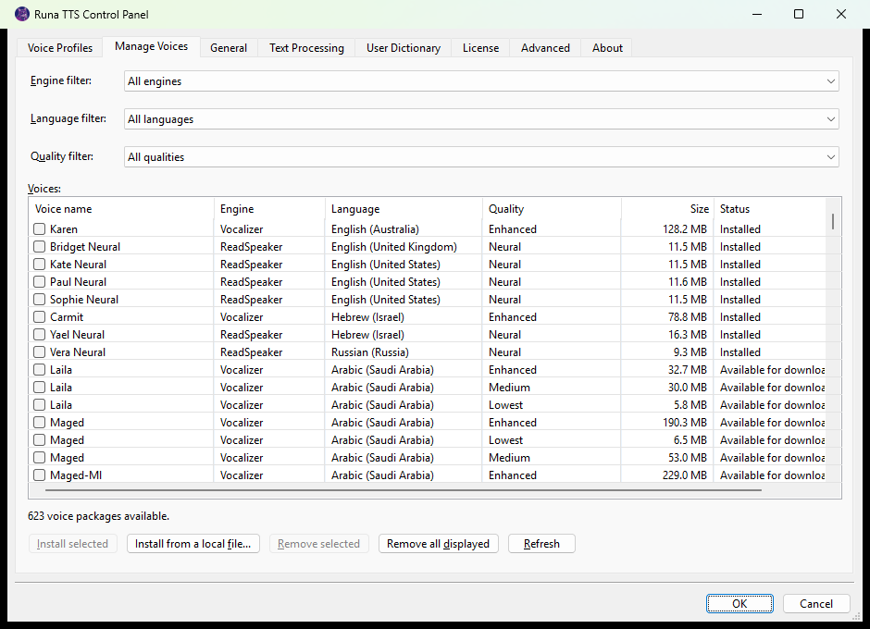
Column | Contents
Voice name | The name you will select in your screen reader.
Engine | ReadSpeaker or Vocalizer.
Language | The language and region, for example Hebrew (Israel).
Quality | See below.
Size | Download size.
Status | Installed, Available for download, or Installed, but incomplete.
The voice list

The Voices list has one row per voice package, with six columns:
Installed voices are listed first, then everything available to download. Within each group, voices are sorted by language name and then by voice name.
Quality values differ between the two families. ReadSpeaker's current voices are all shown as Neural. Vocalizer voices use Premium, Enhanced, Enhanced (classic), Medium, and Lowest. Higher quality generally means a larger download; the only way to choose between two voices of the same language is to listen to them.
A status of Installed, but incomplete means files are missing from an otherwise installed voice. Remove that voice and install it again.
Narrowing the list
There are usually several hundred packages, so use the three combo boxes above the list:
- Engine filter — All engines, Vocalizer, or ReadSpeaker.
- Language filter — All languages, or one language.
- Quality filter — All qualities, or one quality level.
The line below the list reports how many packages match.
Installing
- Set the filters you want.
- Move through the Voices list and press Space on each voice you want. Checked voices are counted in the button label, which changes from Install selected to Install 3 selected.
- Press Install selected.
- Runa downloads each package, verifies it, and installs it. Progress is announced as it goes.
You can check voices from both engines in one operation.
Installing from a file
If you were sent a voice package directly, press Install from a local file... and choose the file. Runa identifies which engine the package belongs to by checking it against its trusted catalogs, so the Engine filter setting does not matter.
Runa verifies every package before installing it. If verification fails, do not rename or unpack the file — get a fresh copy from whoever supplied it.
Removing
Check the installed voices you want gone and press Remove selected, then confirm.
Remove all displayed removes every installed voice that the current filters are showing. Check what the filters are set to before you use it: with All languages and All engines selected, it removes everything you have.
After installing or removing a voice
- Restart any running screen reader. This is required for ReadSpeaker voices, whose voice list is built when the screen reader loads.
- Close and reopen SAPI 5 programs that were already open. Many cache the voice list.
- Reopen the Control Panel if a new voice does not appear in the profile editor.
You never need to run Repair SAPI5 integration after a voice change.
If the catalog is unavailable
Runa keeps the two catalogs independent, so a problem with one does not hide the other. Messages you may see below the list:
- Offline voice catalogs loaded. Only installed voices and local packages are available. — no internet connection. Installed voices keep working.
- The Vocalizer catalog is offline. / The ReadSpeaker catalog is offline. — one provider is unreachable; the other still works.
- A ReadSpeaker catalog failed signature verification and was not used. — Runa rejected catalog data that did not carry a valid signature. This protects you; only trusted data and your installed voices are offered. Press Refresh later, and report it if it persists.
6. Choosing Runa in your screen reader
Runa publishes two kinds of entries to your screen reader:
- Individual voices — a single ReadSpeaker or Vocalizer voice, named as it appears in Manage Voices.
- Runa Profile voices — a profile you configured, named profile name (Runa Profile). These are the ones that carry Smart Switch and the rest of the profile settings.
A clean installation already publishes one profile voice: Runa Smart Switch (Runa Profile).
JAWS and Fusion
The installer places a ready-made RunaTTS voice profile into each JAWS version you selected. It is already configured to use Runa Smart Switch (Runa Profile) for every language context, so Runa — not JAWS — decides which voice speaks which script. It covers US, UK, Australian and New Zealand English, Hebrew, Russian, and Arabic contexts.
To select it:
- Restart JAWS if you have not since installing Runa or changing voices.
- Press Insert+Ctrl+S (Desktop layout) or Caps Lock+Ctrl+S (Laptop layout). JAWS opens Select a Voice Profile.
- Choose RunaTTS and confirm.
You can instead pick any individual Runa voice from the JAWS voice list, but then you lose Smart Switch unless you turn on the option described in Advanced.
A note on the word "profile". JAWS calls its own dialog Select a Voice Profile, and Runa has a feature called Voice Profiles. They are different things. A JAWS voice profile decides what JAWS speaks with; a Runa profile is a bundle of Runa settings. The RunaTTS JAWS profile simply points at the Runa Smart Switch Runa profile.
Rate, pitch, and volume are adjusted with your normal JAWS controls. If they seem to have no effect, the Runa profile has a Force option enabled — see Voice Profiles.
Fusion uses JAWS for speech; follow the JAWS instructions above.
NVDA
Runa's NVDA add-on ships inside the Runa installer, so there is nothing extra to download.
To install it, use whichever is easiest:
- Press Windows, type Install NVDA add-on, and press Enter — this is the Start menu shortcut Runa created; or
- open RunaTTS2.nvda-addon from the NVDA folder inside Runa's program folder (normally C:\Program Files\AccessMind\RunaTTS\NVDA).
NVDA asks you to confirm the installation and then to restart. Say yes to both.
If NVDA happened to be running when you installed Runa, setup offered a check box on its final page to install the add-on for you. If you selected it, it is already done.

To select Runa:
- Press NVDA+Ctrl+S to open Select Synthesizer.
- Choose Runa TTS and confirm.
- Press NVDA+Ctrl+V to open NVDA's Speech settings and choose the voice you want — Runa Smart Switch (Runa Profile) for the full profile behavior, or an individual voice.
NVDA's own rate, pitch, and volume sliders work normally unless a Runa profile forces that parameter.
Where Runa settings live. The add-on connects NVDA to Runa; it does not duplicate Runa's settings. Profiles, Smart Switch, voice downloads, Hebrew pronunciation, number handling, the dictionary, and licensing are all in the Runa TTS Control Panel.
Punctuation. NVDA has its own Symbol level setting, which replaces symbols with spoken words before Runa ever sees the text. If you want Runa's Process punctuation to be in charge, keep NVDA's symbol level low. If you prefer NVDA's symbol handling, keep it and leave Runa's Process punctuation off. Turning both up means both will act.
Running Runa 1.x alongside 2.x. Both add-ons can be installed in the same copy of NVDA and used in the same session. Earlier builds of Runa 2.x could not — whichever synthesizer started second failed to load. If you hit that, you are on an old build; update Runa TTS.
Other SAPI 5 programs
Microsoft SAPI 5 is the standard Windows speech interface. Runa registers itself as a SAPI 5 voice provider for both 64-bit and 32-bit programs, so any SAPI 5 program finds Runa's voices without a Runa plug-in of its own.
- Open the program's speech, voice, or text-to-speech settings.
- If it asks which speech system to use, choose Microsoft SAPI 5 (sometimes written SAPI5 or Speech API Version 5).
- Choose a Runa voice or Runa Smart Switch (Runa Profile).
If you installed or removed voices while the program was open, close and reopen it.

Part 2 — The Control Panel
7. Control Panel basics
Open it from the Start menu: press Windows, type RunaTTS control panel, press Enter.
The window is a set of tabs. In order:
Voice Profiles, Manage Voices, General, Text Processing, User Dictionary, License, Advanced, About.
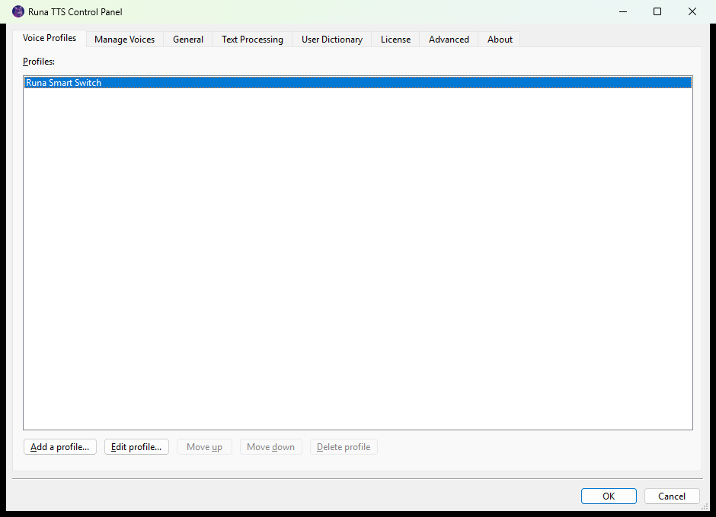
Moving around
Key | Action
Ctrl+Tab / Ctrl+Shift+Tab | Next / previous tab
Tab / Shift+Tab | Next / previous control on the page
Arrow keys | Move within a list or combo box
Space | Select a check box, or check an item in the voice list
Enter | Press the default button
Alt + underlined letter | Jump straight to that control
Alt+F4 or Escape | Close, discarding unsaved changes
OK and Cancel sit at the bottom of the window and apply to the whole Control Panel, not just the visible tab. OK saves everything and closes; Cancel discards everything since you opened it.
The profile editor is the exception — it is a separate dialog with its own OK, Cancel, and Apply buttons.
What each tab is for
Tab | Use it to
Voice Profiles | Create and edit profiles: default voice, Smart Switch, per-voice tuning, sentence pauses, Hebrew pronunciation.
Manage Voices | Download, install, and remove voices.
General | Change the Control Panel's own interface language.
Text Processing | Set capital-letter announcements, punctuation, and long-number reading for all voices.
User Dictionary | Create pronunciation replacements; import and export them.
License | Check status, activate, remove activation.
Advanced | Let individually-selected voices borrow a profile's Smart Switch routing.
About | Product name and version number. Support will ask for this.

8. Voice Profiles
A Voice Profile is a named bundle of speech settings. It holds a default voice, the Smart Switch routing table, per-voice rate/pitch/volume adjustments, forced parameters, sentence pause length, and the Hebrew pronunciation option.
A profile takes effect only when you select that profile as your voice in your screen reader. Selecting an individual voice instead bypasses everything in the profile. (Global Text Processing and the User Dictionary always apply either way.)
The built-in profile
A clean installation creates one profile, Runa Smart Switch, with Smart Switch already enabled and Register as voice already on. It is published to your screen reader as Runa Smart Switch (Runa Profile), and the JAWS voice profile the installer ships points at it.
For most people this profile is the only one they need. Edit it rather than creating a second one.

Creating and editing
On the Voice Profiles tab:
- Add a profile... creates a new one.
- Edit profile... opens the selected profile.
- Move up / Move down change the order profiles are listed in.
- Delete profile removes the selected profile, after confirming.
Either button opens the profile editor, a dialog with four tabs: General, Per-voice Settings, Smart Switch, and Advanced. Move between them with Ctrl+Tab.
The dialog has three buttons: OK saves and closes, Cancel discards, and Apply saves without closing — useful while you are trying settings out.
Profile editor: General
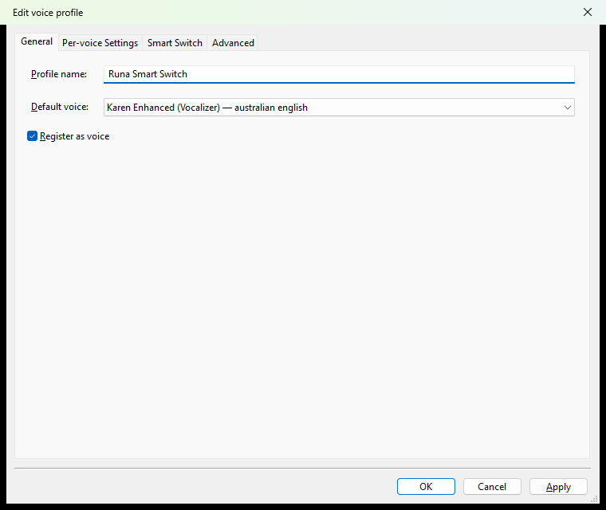
- Profile name — what you will hear when selecting it. Choose something you will recognize in a voice list, such as Work or Hebrew and English.
- Default voice — the profile's home voice. It speaks everything Smart Switch does not route elsewhere, and everything if Smart Switch is off.
- Register as voice — publishes this profile to JAWS, NVDA, and SAPI 5 as name (Runa Profile).
New profiles you create have this switched off. A profile you cannot select from your screen reader is almost always a profile with this box cleared.
Profile editor: Per-voice Settings
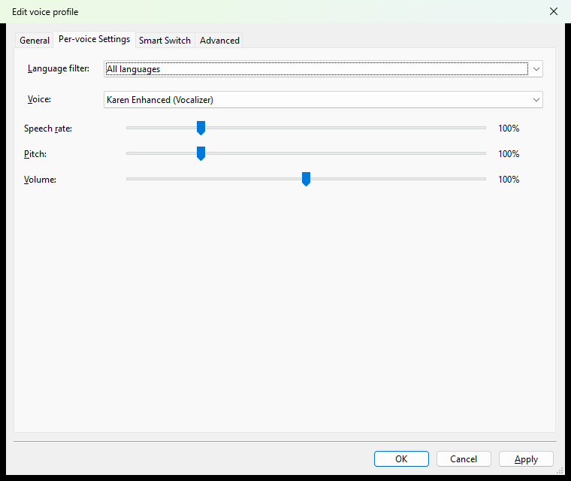
Use this when two voices do not match each other — a common problem when one language's voice sounds much faster or quieter than another's at the same screen-reader setting.
- Narrow the Voice list with the Language filter if you like.
- Choose the Voice to adjust.
- Set Speech rate, Pitch, and Volume.
Each slider is a percentage, and 100% means no change:
Slider | Range | Note
Speech rate | 25%–400% | The upper limit is lower for voices that cannot go that fast.
Pitch | 50%–300%
Volume | 0%–200%
On a slider, Left/Right arrows move by exactly 1 percentage point and Page Up/Page Down by 10.
These percentages scale what your screen reader asks for; they do not replace it. If you set a voice to 80% and then speed JAWS up, that voice still speeds up — it stays 20% slower than the others. That is the point: you are correcting the balance between voices, not fixing their speed. To fix the speed outright, use a Force option on the Advanced tab.
Adjustments are stored per voice, so you can tune several voices in one profile.
Profile editor: Advanced
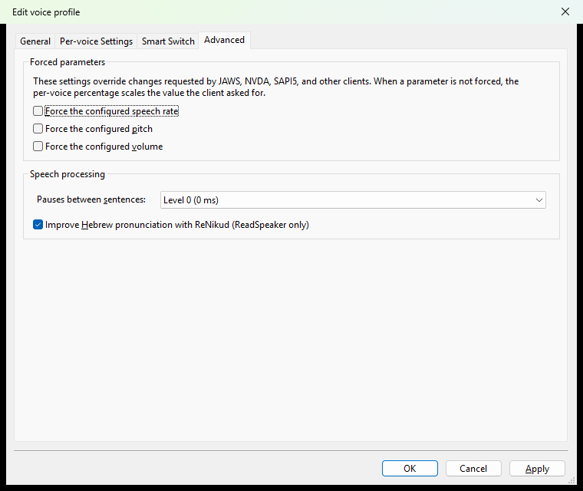
Forced parameters — Force the configured speech rate, Force the configured pitch, Force the configured volume.
Selecting one makes the per-voice percentage an absolute value and makes Runa ignore that parameter when JAWS, NVDA, or a SAPI 5 program asks to change it. The other two parameters are unaffected.
Leave these off unless you have a reason. With them off you keep normal control from your screen reader. The usual reason to switch one on is a program that insists on a rate you do not want.
If your screen reader's rate or volume keys suddenly do nothing, this is why.
Pauses between sentences — Level 0 to Level 9, where each level adds 200 milliseconds: Level 0 adds nothing, Level 5 adds one second, Level 9 adds 1.8 seconds. The default is Level 0. Raise it if sentences run into each other.
Improve Hebrew pronunciation (ReadSpeaker only) — passes Hebrew text through a smart AI model before it is spoken. The model works out how each word is meant to be read in the sentence it appears in, so the voice pronounces far more words correctly than it would on its own.
The difference is clearest in ordinary prose and in names, where the same written word can be read more than one way. As the label says, it applies to ReadSpeaker Hebrew voices only; Vocalizer Hebrew voices ignore it. It is on by default, and there is no reason to turn it off unless you want to compare it against the untreated voice.
9. Smart Switch
Smart Switch is Runa's automatic voice switching. It examines the characters in the text and sends each run to the voice you chose for that writing system — so a Hebrew sentence quoting an English phrase is read by two voices, correctly, without you doing anything.
What it can and cannot do
Smart Switch works on writing systems, not languages. It reliably distinguishes Hebrew from Latin from Cyrillic, because those use different characters.
It cannot tell English from French, Spanish, or German. Those all use Latin letters, so they all take the Latin route. This is a real limit, not a setting you have missed. If you need to switch between two Latin-script languages, select a different Runa voice for that task.
Setting it up
Edit a profile and go to the Smart Switch tab.
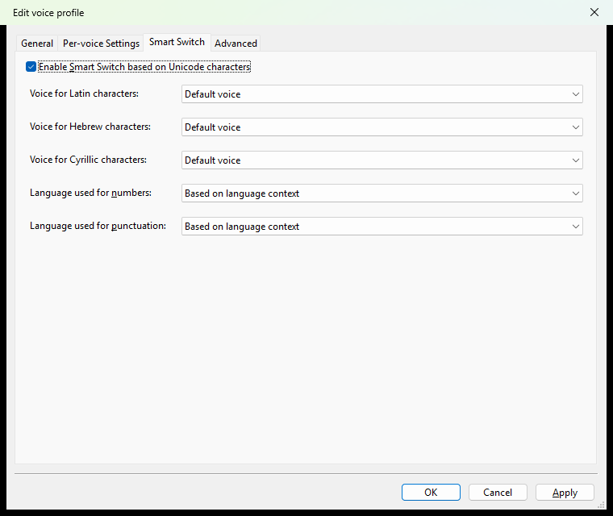
- Select Enable Smart Switch based on Unicode characters. Everything below it becomes available.
- For each Voice for script characters row, choose the voice for that writing system. Leaving a row on Default voice means that script is spoken by the profile's default voice.
- Set Language used for numbers and Language used for punctuation.
Runa supports Latin, Hebrew, Arabic, Greek, Cyrillic, and CJK (Chinese, Japanese, and Korean).
Rows appear only for scripts you have a voice for. If there is no Voice for Arabic characters row, you have no Arabic voice installed. Install one in Manage Voices, reopen the Control Panel, and the row will be there. This is the single most common source of confusion with Smart Switch. In the screenshot above only Latin, Hebrew and Cyrillic appear, because only English, Hebrew and Russian voices are installed on that machine.

Numbers and punctuation
Digits and punctuation belong to no writing system, so you tell Runa what to do with them:
- Based on language context — speak them in whichever language surrounds them. This is the sensible default and what the built-in profile uses.
- Default voice — always the profile's default voice.
- None (punctuation only) — do not give punctuation a route of its own; it stays with the text around it.
How much punctuation is spoken is a separate, global setting — see Text Processing.
Worked example: Hebrew and English
- Install at least one Hebrew voice and one English voice, and restart your screen reader.
- Open the Control Panel, Voice Profiles, select Runa Smart Switch, press Edit profile....
- On General, set Default voice to the voice you use most.
- On Smart Switch, confirm Enable Smart Switch based on Unicode characters is selected.
- Set Voice for Latin characters to your English voice and Voice for Hebrew characters to your Hebrew voice.
- Leave numbers and punctuation on Based on language context.
- Press OK, then OK again to close the Control Panel.
- Select Runa Smart Switch (Runa Profile) in your screen reader.
Mixed Hebrew and English text is now read by both voices.
10. Text Processing
These settings are global. They apply to every Runa voice — ReadSpeaker, Vocalizer, and profile voices alike — and are not part of any profile.
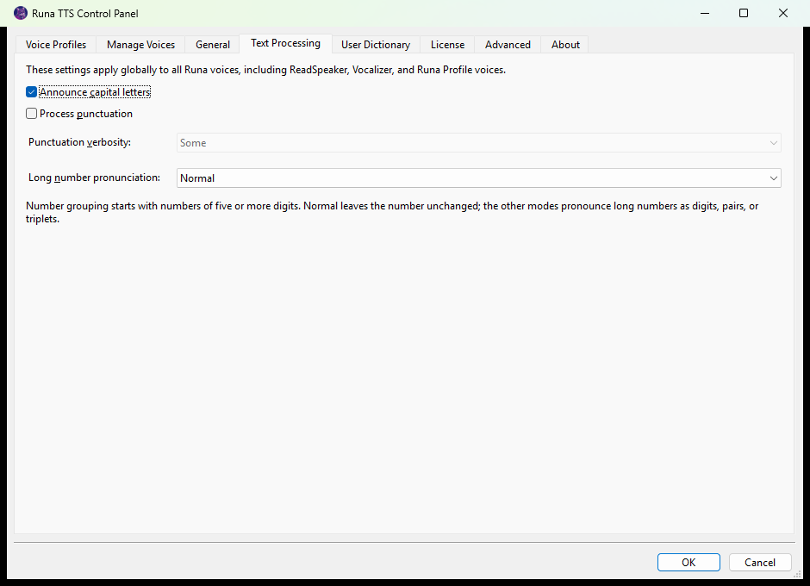
Announce capital letters — Runa says that a letter is capital when you spell or move character by character. It works for any cased script, not only English.
Your screen reader may already indicate capitals with a pitch change. That is a separate feature; if you turn both on you get both.
Process punctuation — lets Runa apply its own punctuation verbosity. Off by default.
Punctuation verbosity — None, Some, Most, or All. This combo box is grayed out until Process punctuation is selected; if you cannot change it, that is why. Some is a good starting point: common, useful punctuation without every symbol.
Note that your screen reader has its own punctuation setting, and it acts first. If NVDA or JAWS has already turned a symbol into a word, Runa receives the word. Turn one of them down.
Long number pronunciation — how Runa reads long runs of digits:
Setting | Effect
Normal | Leaves the number as it is. The default.
Individual digits | One digit at a time — best for reference numbers.
Pairs | Two digits at a time.
Triplets | Three digits at a time.
Grouping starts at five digits. Shorter numbers are always read normally, whatever you choose here.
11. User Dictionary
The dictionary replaces text before it is spoken. Use it for names, abbreviations, technical terms, and anything a voice gets wrong.
It is global — one dictionary for all voices, all profiles, and all programs.
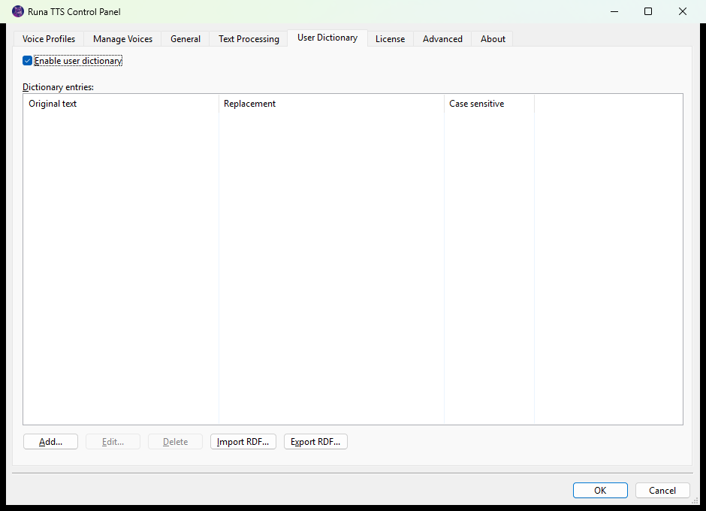
Adding an entry
- Make sure Enable user dictionary is selected.
- Press Add....
- In Original text, type the word or phrase as it is written.
- In Replacement, type it as it should be spoken — spell it the way that produces the right sound, not the way it is spelled properly.
- Select Match case only if the entry should apply only to that exact capitalization.
- Press OK.
Both fields are required.
Use Edit... and Delete to change or remove the selected entry.
Backing up and transferring
- Export RDF... writes your entries to a Runa Dictionary File (.RDF), suggested name RunaDictionary.RDF. Keep it as a backup.
- Import RDF... reads entries back in from such a file.
The .RDF format is portable between Runa installations, so this is how you move your dictionary to a new computer.
12. Advanced
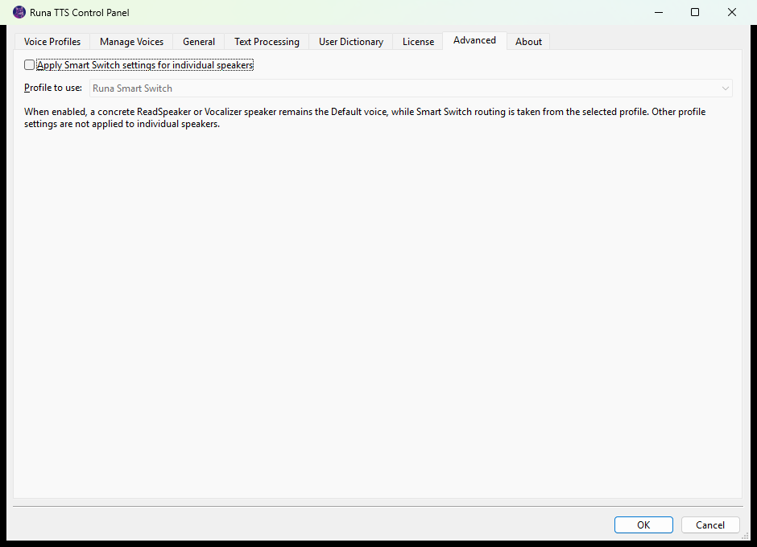
This tab does one thing, and most people never need it.
Normally, choosing an individual voice in your screen reader turns off everything profiles do, including Smart Switch. Apply Smart Switch settings for individual speakers changes that: it lets a directly-selected voice borrow the Smart Switch routing from a profile you nominate in Profile to use.
To use it, select the check box, choose a profile, and then select an individual voice in your screen reader as usual.
Only the routing is borrowed. The voice you selected stays the default voice. The nominated profile's own default voice, per-voice percentages, force settings, sentence pause, and Hebrew pronunciation setting are not applied. The profile does not need Register as voice enabled for this.
Use it when you want to keep choosing voices directly from your screen reader but still want Runa to switch scripts for you.
13. General and About
General
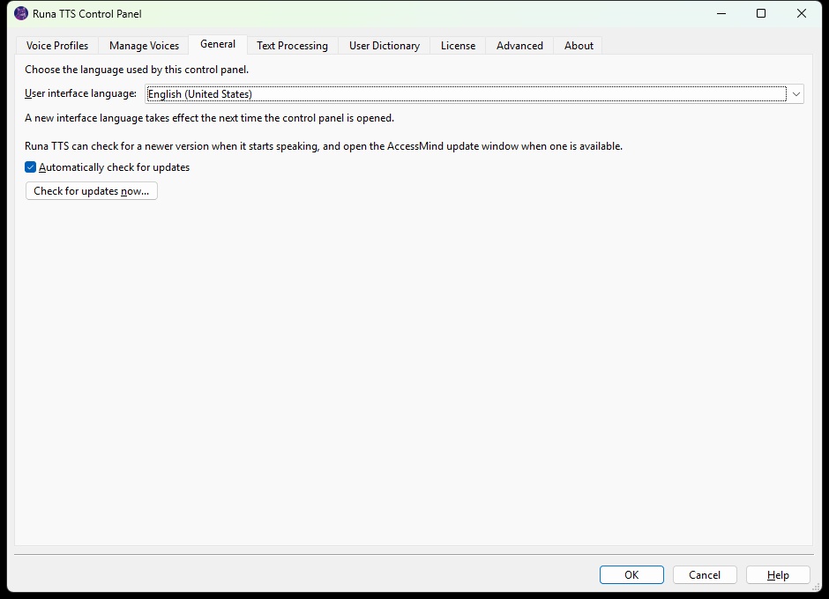
User interface language sets the language of the Control Panel itself. It does not affect speech, voices, or Smart Switch. Match system language follows Windows.
A change takes effect the next time you open the Control Panel. The Control Panel says so when you change it.
Automatically check for updates is on to begin with. With it on, Runa asks once each time it starts speaking in a program whether a newer version of Runa TTS has been released, and opens the AccessMind update window if there is one. The check is quiet: it happens in the background a few seconds after Runa starts, nothing appears if there is no update, and nothing appears if the check could not be made — being offline is never reported as being up to date. You will not get one window per program either, however many of them are speaking.
Check for updates now opens the same window straight away, whether or not the automatic check is on. That window lists what is available with its release notes, says separately what it could not check, and asks you to close any program it needs to close before it installs anything.
Updates never depend on your license. A license that has lapsed still receives fixes.
About
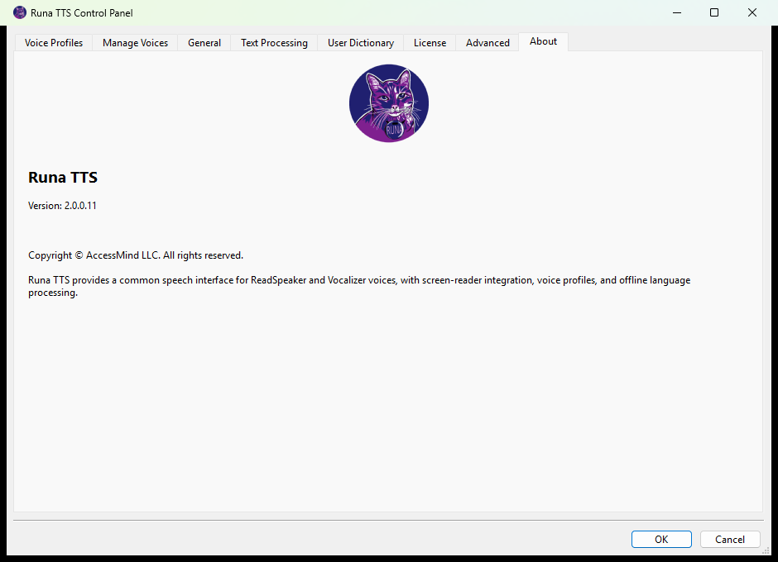
Shows the product name and the Version number. Have this ready when you contact support.

Part 3 — Reference
14. Everyday setups
You read one language and want the least fuss. You do not need a profile at all. Install one voice, select it directly in your screen reader, and set Text Processing and the User Dictionary to taste. Done.
You read two writing systems every day. Use the built-in Runa Smart Switch profile. Install a voice for each script, set the two routes on the Smart Switch tab, and select Runa Smart Switch (Runa Profile) once. Leave it selected.
One voice is much faster or quieter than another. Edit the profile, go to Per-voice Settings, and adjust the mismatched voice by a percentage. Leave the Force options off so your screen reader still controls the overall speed.
Sentences run together when reading long documents. Create a second profile for reading, raise Pauses between sentences to Level 2 or 3, register it as a voice, and switch to it when you sit down to read.
A name is always mispronounced. One User Dictionary entry fixes it everywhere — every voice, every program.
Numbers matter more than speed. Set Long number pronunciation to Individual digits. Reference numbers, account numbers and codes become far easier to take down.
15. Troubleshooting
Runa does not appear in JAWS
- Restart JAWS. This is the answer most of the time.
- Run the Runa installer again and confirm your JAWS version is checked on the JAWS Driver Installation page.
- If a profile you made is the thing missing, edit it and select Register as voice.
Runa does not appear in NVDA
- Confirm the Runa TTS Windows product is installed, not just the add-on.
- Open NVDA's Add-on Store and check the Runa add-on is installed and enabled.
- Restart NVDA, then press NVDA+Ctrl+S and look again.
A newly installed voice is missing
- Restart your screen reader. Required for ReadSpeaker voices.
- Close and reopen the Control Panel.
- Check the voice's Status in Manage Voices really says Installed. If it says Installed, but incomplete, remove it and install it again.
- For SAPI 5 programs, close and reopen the program.

A profile does not appear as a voice
Edit it and select Register as voice — it is off by default on profiles you create. Save, then restart the screen reader.
Smart Switch is not switching
Work down this list:
- Are you using the (Runa Profile) voice? An individual voice ignores Smart Switch unless you enabled the Advanced option.
- Is Enable Smart Switch based on Unicode characters selected in that profile?
- Is there a row for the script? If the row is missing, the voice is missing. Install a voice for that language and reopen the Control Panel.
- Are the two languages both Latin-script — English and French, say? Smart Switch cannot separate those. This is a limitation, not a fault.
There is no row for a script I need
You have no installed voice for it. Install one in Manage Voices, restart your screen reader, and reopen the Control Panel.
My screen reader's rate or volume keys do nothing
Edit the profile you are using, go to Advanced, and clear the relevant Force option. A forced parameter deliberately overrides the screen reader.
Punctuation is spoken oddly in NVDA
NVDA's Symbol level acts before Runa's Process punctuation, so both may be processing the same symbol. Turn one of them down. If you want Runa in charge, lower NVDA's symbol level.
Improved Hebrew pronunciation makes no difference
Check that the voice you are hearing is a ReadSpeaker Hebrew voice. The setting does not apply to Vocalizer voices — the check box itself says so.
The License tab says AccessMind Runtime is not installed
Licensing cannot run. Repair Runa by running the installer again over the existing installation.
Voices cannot be managed at all
If Manage Voices says no voice engines are available because Runa is not activated, activate on the License tab first.
Runa is not licensed even though I activated
Close and reopen the Control Panel, then restart your screen reader. If the status stays wrong, note exactly what the License tab says and contact support.
No SAPI 5 program can see Runa
- Restart the program.
- Confirm it really supports SAPI 5.
- Run Repair SAPI5 integration from the Start menu.
- If that fails, repair the installation with the installer.
16. Quick reference
Where do I change this?
I want to... | Go to
Install or remove voices | Manage Voices
Activate or deactivate | License
Set up multilingual reading | Voice Profiles → edit → Smart Switch
Balance two voices' speed or volume | Voice Profiles → edit → Per-voice Settings
Change sentence pauses or Hebrew pronunciation | Voice Profiles → edit → Advanced
Make a profile selectable in my screen reader | Voice Profiles → edit → General → Register as voice
Capital letters, punctuation, long numbers | Text Processing
Fix a mispronounced word | User Dictionary
Use Smart Switch with a directly-chosen voice | Advanced
Change the Control Panel's language | General
Find the version number | About

Keystrokes
Where | Key | Action
Control Panel | Ctrl+Tab | Next tab
Control Panel | Alt + underlined letter | Jump to a control
Sliders | Left / Right | Change by 1%
Sliders | Page Up / Page Down | Change by 10%
Voice list | Space | Check or uncheck a voice
JAWS | Insert+Ctrl+S | Select a Voice Profile (Desktop layout)
JAWS | Caps Lock+Ctrl+S | Select a Voice Profile (Laptop layout)
NVDA | NVDA+Ctrl+S | Select Synthesizer
NVDA | NVDA+Ctrl+V | Speech settings

Value ranges
Setting | Range | Default
Per-voice speech rate | 25%–400% (voice-dependent maximum) | 100%
Per-voice pitch | 50%–300% | 100%
Per-voice volume | 0%–200% | 100%
Pauses between sentences | Level 0–9, 200 ms per level | Level 0
Punctuation verbosity | None, Some, Most, All | Some (inactive until Process punctuation is on)
Long number grouping | applies from 5 digits | Normal

File locations
What | Where
Program files | %ProgramFiles%\AccessMind\RunaTTS
Settings and profiles | %APPDATA%\AccessMind\RunaTTS
User dictionary | %APPDATA%\AccessMind\RunaTTS\user-dict
ReadSpeaker voices | %ProgramData%\AccessMind\RunaTTS\Voices\ReadSpeaker
Vocalizer voices | %ProgramData%\AccessMind\RunaTTS\Voices\Cerence
NVDA add-on file | %ProgramFiles%\AccessMind\RunaTTS\NVDA\RunaTTS2.nvda-addon

To back up your setup, copy %APPDATA%\AccessMind\RunaTTS and export your dictionary with Export RDF....
Before contacting support
Have these ready:
- The Version from the About tab.
- Your screen reader or program, and its version.
- The exact name of the Runa voice or profile you had selected.
- What the License tab says, if the problem involves licensing.
- A short example: what you expected to hear, and what you actually heard.

Runa TTS is a product of AccessMind LLC. © 2026 AccessMind LLC. All rights reserved.

